**FINAL PROJECT**

**RURAL MUNICIPALITY CROP YIELD**

**INTRODUCTION**

The objective of this project is to analyze the Rural Municipality Crop Yield data from 1938 to 2021. The Rural Municipality Yield Data contains the yield data for crops in rural municipalities starting from 1938 to 2021.The project will identify any trends, patterns, distributions or insights from the yield data.

**DATA COLLECTION AND PREPROCESSING**

There are two data sources for this project:

the Crop Yield Reading Crop_Yield Data df = pd.read_csv('rm_crop_yields_1938_2021.csv')

and the GIS (Rural Municipality) data dfm = gpd.read_file('Rural Municipality\Rural Municipality.shp')

.

**ETL (Extract, Transform, Load)**

The following installation and libraries were imported and used for this project:

import pandas as pd

import numpy as np

import geopandas as gpd

import matplotlib.pyplot as plt

import seaborn as sb

plt.rcParams['figure.figsize'] = (20, 12)

! pip install folium matplotlib mapclassify

import pandas as pd

from sklearn.linear_model import LinearRegression

from sklearn.model_selection import train_test_split

import matplotlib.pyplot as plt

import matplotlib.colors

The ETL includes:

* Renaming the columns in Rural Municipality Data

Rename the columns of Rural Municipality Data

dfm.rename(columns=

{

    'PPID': 'ID',

    'EFFDT': 'Year',

    'RMNM': 'RMNAME',

    'RMNO': 'RM',

    'SHAPE_AREA': 'Area',

    'SHAPE_LEN': 'Length',

    'geometry': 'Geometry'

}, inplace=True)

* Checking for unique and missing values in the Crop Yield and GIS data

 number of unique values in the RM column

df['RM'].unique()

df['Year'].nunique()

* Changing data type of both the RMs to string

coverting RM and Ycolumn to string

df['RM']=df['RM'].astype('string')

dfm['RM']=dfm['RM'].astype('string')

* Merging the two data frames on RM and including the Geometry in the merged data frame

df_gdf = (

    gpd.GeoDataFrame(pd.merge(df.groupby('RM').mean().reset_index(), dfm[['RM','Geometry']], on='RM'))

    .set_geometry('Geometry')

)

**Exploratory Data Analysis (EDA)**

Data visualization was performed to determine pattern and trends among the crops and across the municipalities, and this includes:

Correlation marix plot

Feature selection with correlation plot was performed to investigate the magnitude of relationships among the crops without RM and Year.

Data preprocessing was done before exploring the data and these include:

* Filling the null values with the average crop yield values
* Dropping the RM and Year for the new data frame

sb.heatmap(df_uns.drop(['RM'], axis = 1).corr(),annot=True,cmap='coolwarm')

Grouped Bar Chart analysis

**Average crop yield by RM**

This was done to show the average each crop yield for each year and for each RM

df.groupby('RM')['Winter Wheat'].mean()\

    .sort_values()[:-250]\

        .plot(

            kind='barh',

            figsize=(20,10),

            color='green')

plt.title(

    'Barley by RM',

    size=18,

    color='gray')

plt.xlabel(

    'Barley Yield',

    color='gray',

    size=16)

plt.ylabel(

    'RM',

    color='gray',

    size=18)

plt.legend()

plt.show()

**Average Yield of Crop in Rural Municipality with respect to Year**

This was done to show the average each crop yield for each year

#Average Yield of Winter Wheat in Rural Municipality with respect to Year

df.groupby('Year')['Winter Wheat'].mean()\

    .sort_values()\

        .plot(kind='bar')

#Average Yield of Canola in Rural Municipality with respect to Year

df.groupby('Year')['Canola'].mean()\

    .sort_values()\

        .plot(kind='bar')

#Average Yield of Spring Wheat in Rural Municipality with respect to Year

df.groupby('Year')['Spring Wheat'].mean()\

    .sort_values()\

        .plot(kind='bar')

#Average Yield of Mustard in Rural Municipality with respect to Year

df.groupby('Year')['Mustard'].mean()\

    .sort_values()\

        .plot(kind='bar')

#Average Yield of Durum in Rural Municipality with respect to Year

df.groupby('Year')['Durum'].mean()\

    .sort_values()\

        .plot(kind='bar')

#Average Yield of Sunflowers in Rural Municipality with respect to Year

df.groupby('Year')['Sunflowers'].mean()\

    .sort_values()\

        .plot(kind='bar')

#Average Yield of Oats in Rural Municipality with respect to Year

df.groupby('Year')['Oats'].mean()\

    .sort_values()\

        .plot(kind='bar')

#Average Yield of Lentils in Rural Municipality with respect to Year

df.groupby('Year')['Lentils'].mean()\

    .sort_values()\

        .plot(kind='bar')

#Average Yield of Peas in Rural Municipality with respect to Year

df.groupby('Year')['Peas'].mean()\

    .sort_values()\

        .plot(kind='bar')

#Average Yield of Spring Wheat in Rural Municipality with respect to Year

df.groupby('Year')['Spring Wheat'].mean()\

    .sort_values()\

        .plot(kind='bar')

#Average Yield of Barley in Rural Municipality with respect to Year

df.groupby('Year')['Barley'].mean()\

    .sort_values()\

        .plot(kind='bar')

#Average Yield of Fall Rye in Rural Municipality with respect to Year

df.groupby('Year')['Fall Rye'].mean()\

    .sort_values()\

        .plot(kind='bar')

#Average Yield of Canary Seed in Rural Municipality with respect to Year

df.groupby('Year')['Canary Seed'].mean()\

    .sort_values()\

        .plot(kind='bar')

#Average Yield of Spring Rye in Rural Municipality with respect to Year

df.groupby('Year')['Spring Rye'].mean()\

    .sort_values()\

        .plot(kind='bar')

#Average Yield of Tame Hay in Rural Municipality with respect to Year

df.groupby('Year')['Tame Hay'].mean()\

    .sort_values()\

        .plot(kind='bar')

#Average Yield of Flax in Rural Municipality with respect to Year

df.groupby('Year')['Flax'].mean()\

    .sort_values()\

        .plot(kind='bar')

#Average Yield of Chickpeas in Rural Municipality with respect to Year

df.groupby('Year')['Chickpeas'].mean()\

    .sort_values()\

        .plot(kind='bar')

**Mapping of crop yield in Rural Municipalities**

GraphDataFrame (gdf) module was used to perform a univariate analysis of each crop for the entire RM.

**METHODOLOGY**

**Supervised Machine Learning**

Linear Regression Analysis

The dataset comprising of Year and Canola was loaded and then split into training and testing sets using the train_test_split function from the sklearn.model_selection module. The independent variable (Year) was assigned to X_train and X_test, and the dependent variable (Canola) is assigned to y_train and y_test. A linear regression model was created using the LinearRegression class from the sklearn.linear_model module. The fit method was used to fit the model to the training data, and the score method was used to evaluate the model's performance on the testing data. The R-squared measured how well the linear regression model fits the data.

The Mean_Absolute_Error (MAE) function was imported from the sklearn. Metrics module. The function takes two arguments: the actual values of the dependent variable (y_test), and the predicted values of the dependent variable (y_pred). The MAE is a metric used to measure the average absolute difference between the actual and predicted values of the dependent variable. By calculating the MAE, we can determine how well the model's predictions match the actual values on average. A lower MAE indicates that the model is making predictions that are more accurate. Therefore, the MAE is an important metric to evaluate the performance of regression models, especially when the magnitude of the error is important to consider.

Arima model

ARIMA model analysis was performed to fit a training Canola/Year dataset and print a summary of the model. The data wa split into training and testing sets using the train_test_split function from the sklearn.model_selection module. The independent variable (Year) is assigned to X_train and X_test, and the dependent variable (Canola) is assigned to y_train and y_test. Next, a pandas DataFrame was created using the training data, with the independent variable as Year and the dependent variable as Canola. Then, an ARIMA model was fitted to the dependent variable, Canola using the ARIMA class from the statsmodels.tsa.arima_model module. Finally, the summary method is called on the fitted model, which prints a summary of the model to the console. The summary includes information about the model's coefficients, statistical significance, goodness of fit, and other diagnostic measures.

Time series Analysis

This analysis was performed to display trends and patterns in time-series data, allowing us to identify long-term patterns, year trends in the Canola/Year data.  
 **2. Unsupervised Machine Learning**

Clustering Analysis

Means and standard deviation of each crop for each RM were computed.

Features was created and data was selected for Features to define data frame X. TK-means was defined and applied and then added to the data frame X. The code then groups the data by clusters, where 'features' is a list of features that are used to perform clustering. The means and standard deviations of the features for each cluster are then computed and stored in the 'cluster_means' and 'cluster_stds' DataFrames respectively. Finally, the code performs a loop over a list of values for 'n_clusters', and for each value of 'n_clusters', it uses the KMeans algorithm to cluster the data into 'n_clusters' clusters, computes the Within-Cluster Sum of Squares (WCSS), and appends it to a list 'wcss'. This WCSS value is a measure of how well the clustering algorithm is able to cluster the data into 'n_clusters' clusters, with a lower value indicating better clustering. Overall, the code is used to analyze the data stored in 'rm_crop_yields_1938_2021.csv' using the KMeans clustering algorithm, and to determine the optimal number of clusters based on the WCSS values.

Scatter plot Analysis

For the scatter plot Analysis, the following steps were taken to plot scatter graph:

* Define x and y and X labels
* Define colors for each cluster
* Plot the data
* Visualize clusters

Elbow method

Elbow method analysis for determining the optimal number of clusters in a KMeans clustering algorithm. In this method, the within-cluster sum of squares (WCSS) was computed for different numbers of clusters, and the resulting values are plotted against the number of clusters. The "elbow" of the plot represents the point of diminishing returns, where adding more clusters does not significantly decrease the WCSS. The model performs KMeans clustering with varying numbers of clusters, computes the WCSS for each clustering, and then plots the results in a graph. This allows for the to visually inspect the plot and determine the optimal number of clusters for the dataset.

**RESULTS AND DISCUSSIONS**

1. **Feature selection - Correlation Matrix plot (Fig 1)**

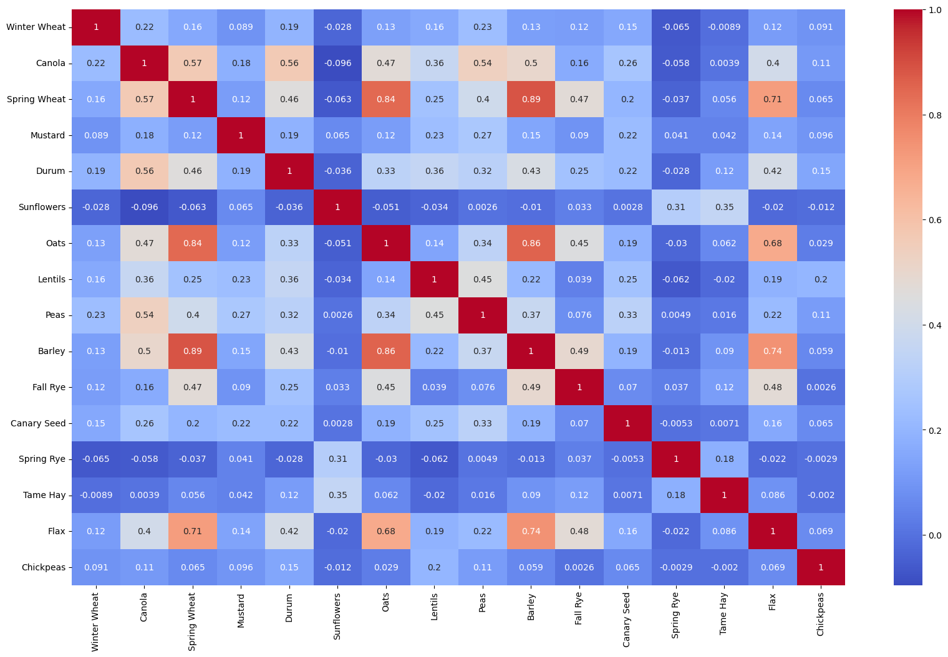

The highest correlation value, 0.89 was found in Barley/ Spring Wheat. Oats/Barley, SpringWheat/Oats, Flax/SpringWheat, have lues of 0.86, 0.84, 0.71 respectively. However, Springwheat/Flax, Oats/Flax and Barley/Flax have equally high to moderate values of 0.71, 0.68 and 0.74 respectively. Canola/Sunflowers, Winterwheat/SpringRye, Canola/SpringRye and Lentils/SpringRye have values -0.096, -0.065, -0.056, -0.0.62 respectively. The strong correlation values in Oats/Barley, SpringWheat/Oats, Flax/SpringWheat might be due to similar climatic factors such as precipitation, sunshine, and inputs.

Grouped Bar Chart analysis (Fig 2: Average Yield of Winter Wheat in Rural Municipality with respect to Year

1. **)**

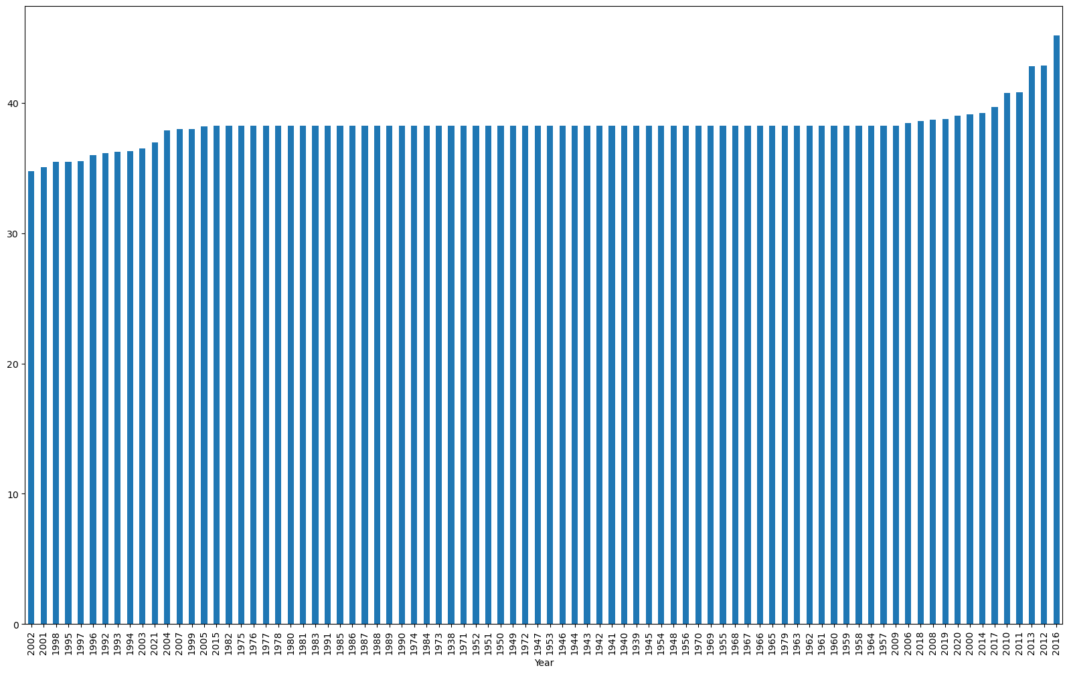

Grouped Bar Chart analysis (Fig 3: Average Yield of Canola in Rural Municipality with respect to Year

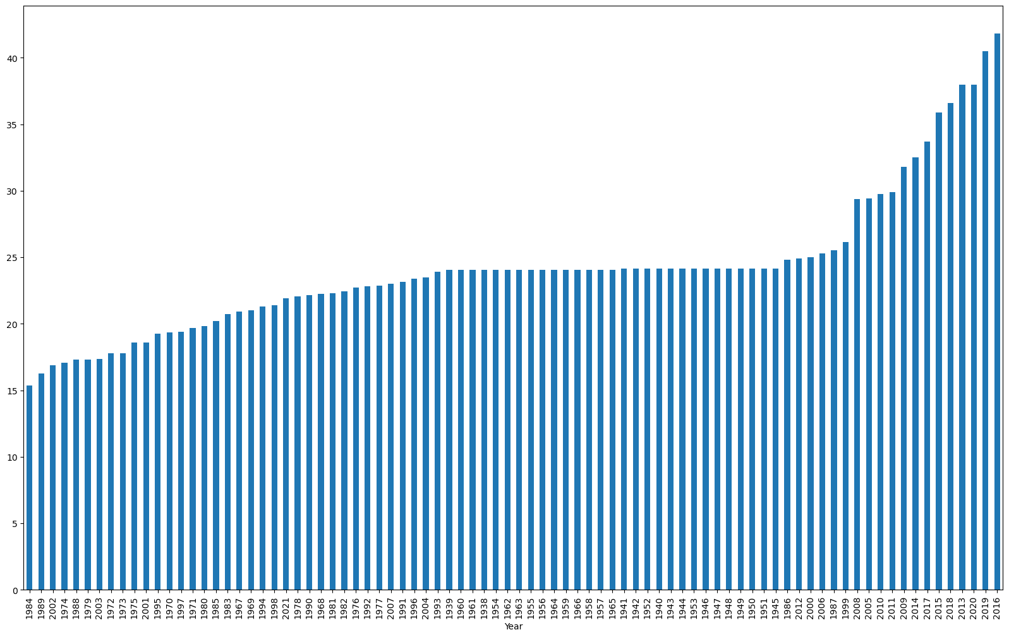

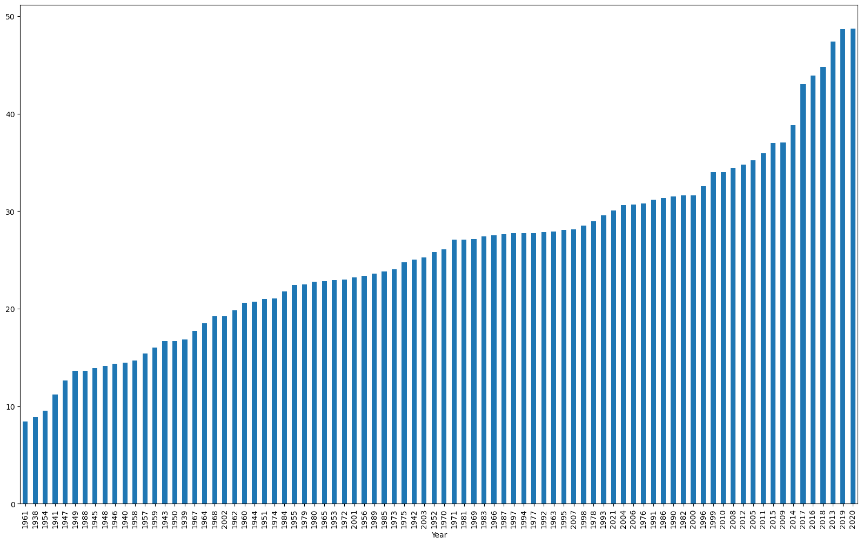

Grouped Bar Chart analysis (Fig 4: Average Yield of Spring Wheat in Rural Municipality with respect to Year

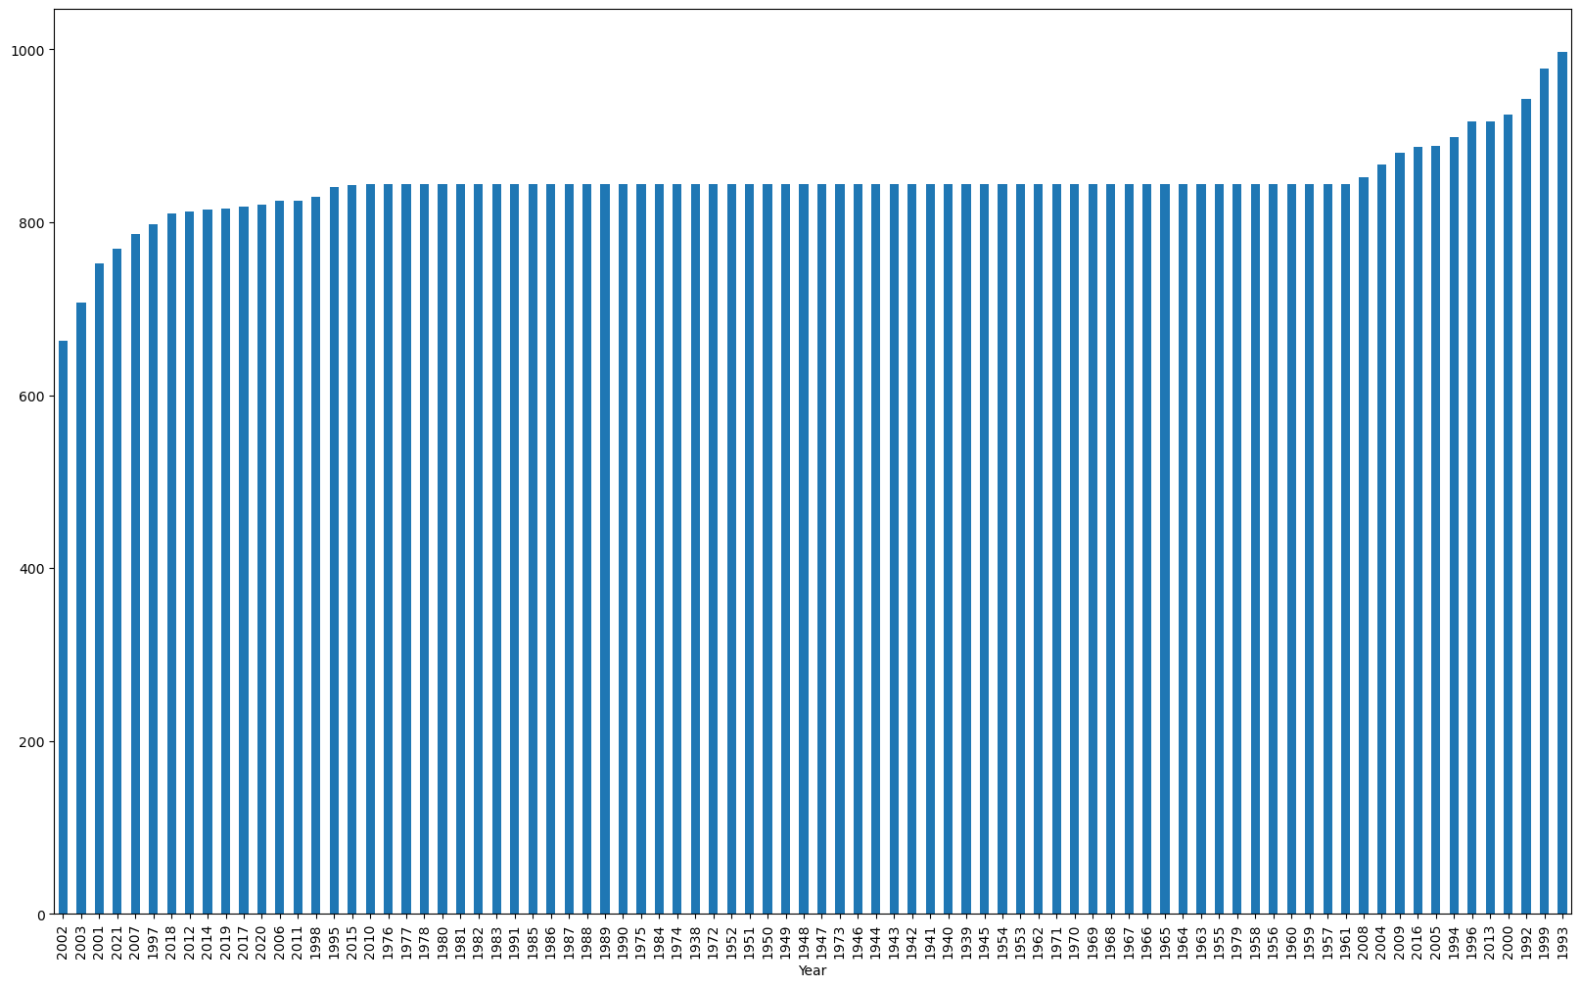

Grouped Bar Chart analysis (Fig 5: Average Yield of Mustard in Rural Municipality with respect to Year

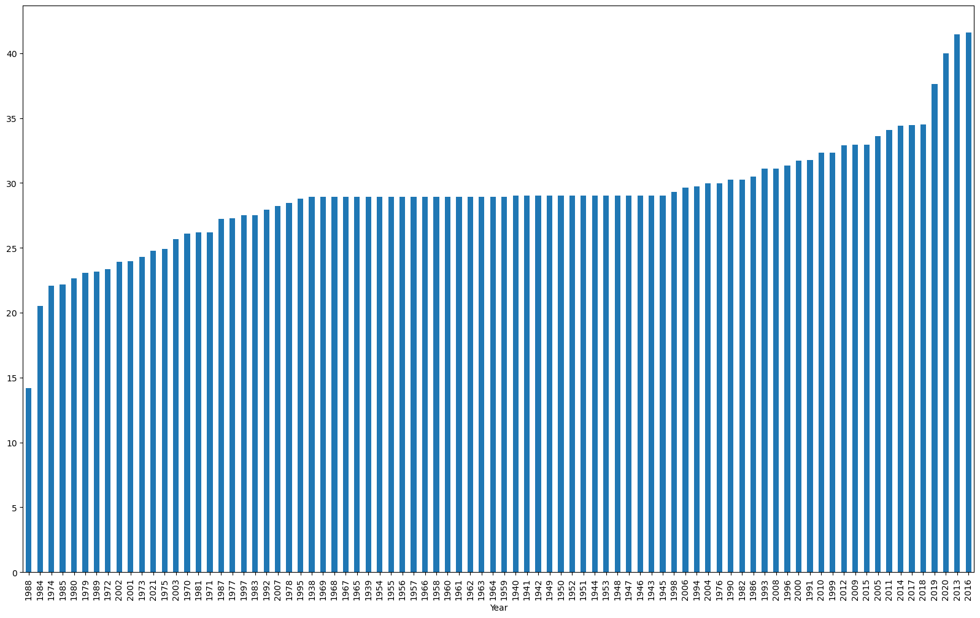

Grouped Bar Chart analysis (Fig 6: Average Yield of Durum in Rural Municipality with respect to Year

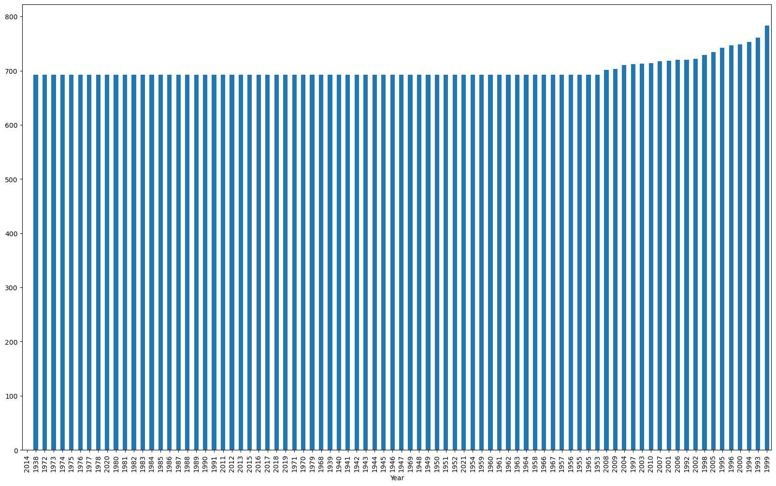

Grouped Bar Chart analysis (Fig 7: Average Yield of Sunflowers in Rural Municipality with respect to Year

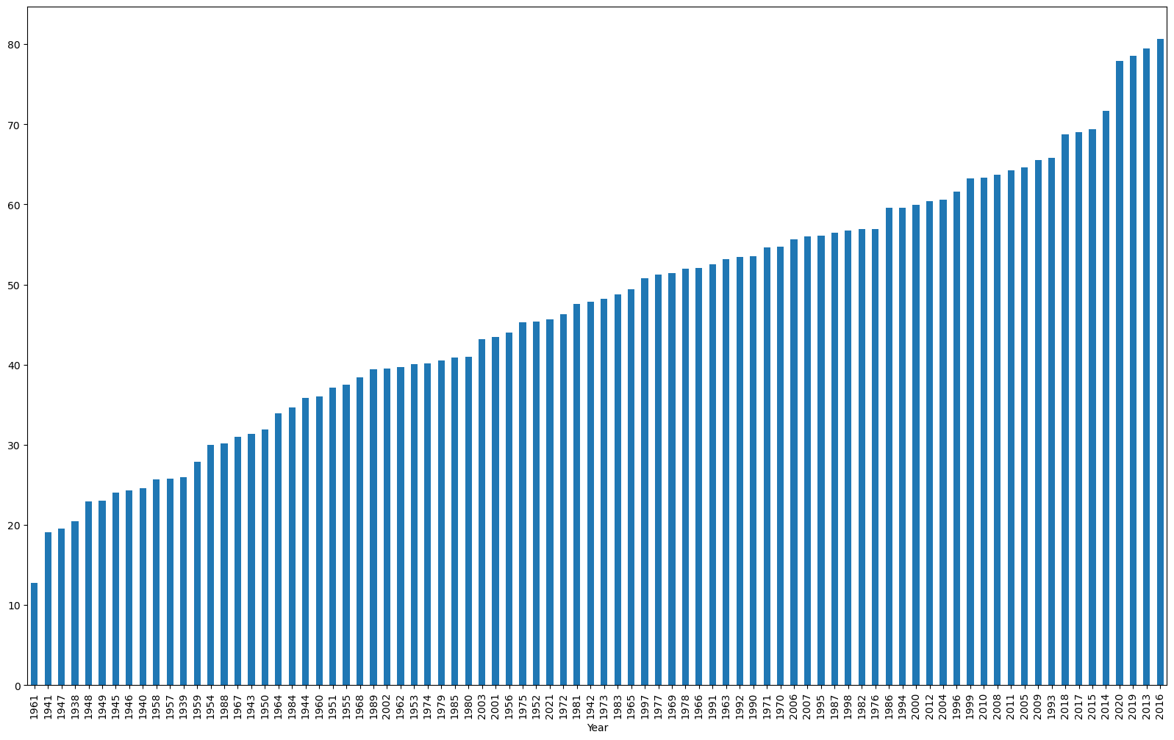

Grouped Bar Chart analysis (Fig 8: Average Yield of Oats in Rural Municipality with respect to Year

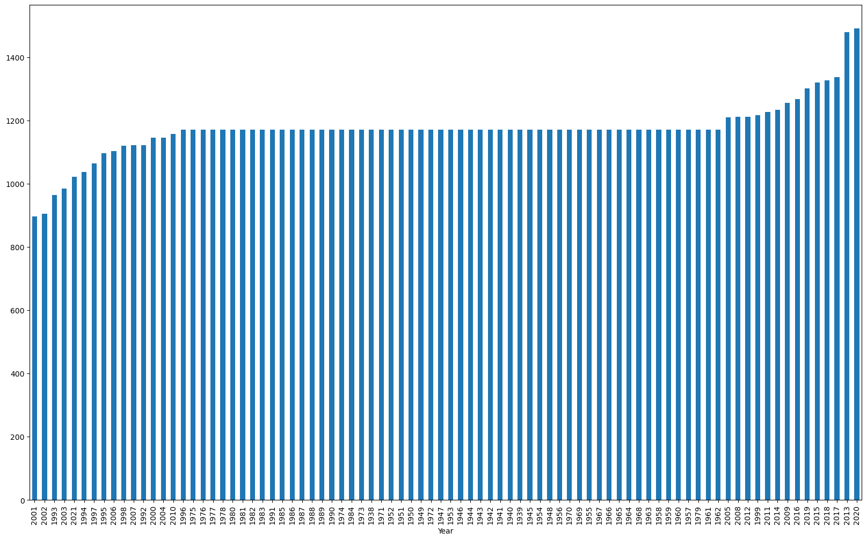

Grouped Bar Chart analysis (Fig 9 Average Yield of Lentils in Rural Municipality with respect to Year

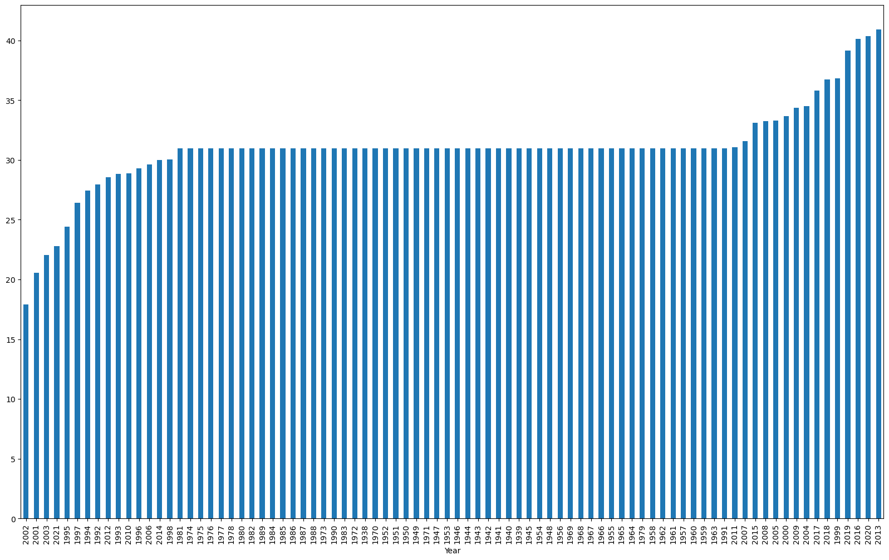

Grouped Bar Chart analysis (Fig 10 Average Yield of Peas in Rural Municipality with respect to Year



Grouped Bar Chart analysis (Fig 11 Average Yield of Spring Wheat in Rural Municipality with respect to Year

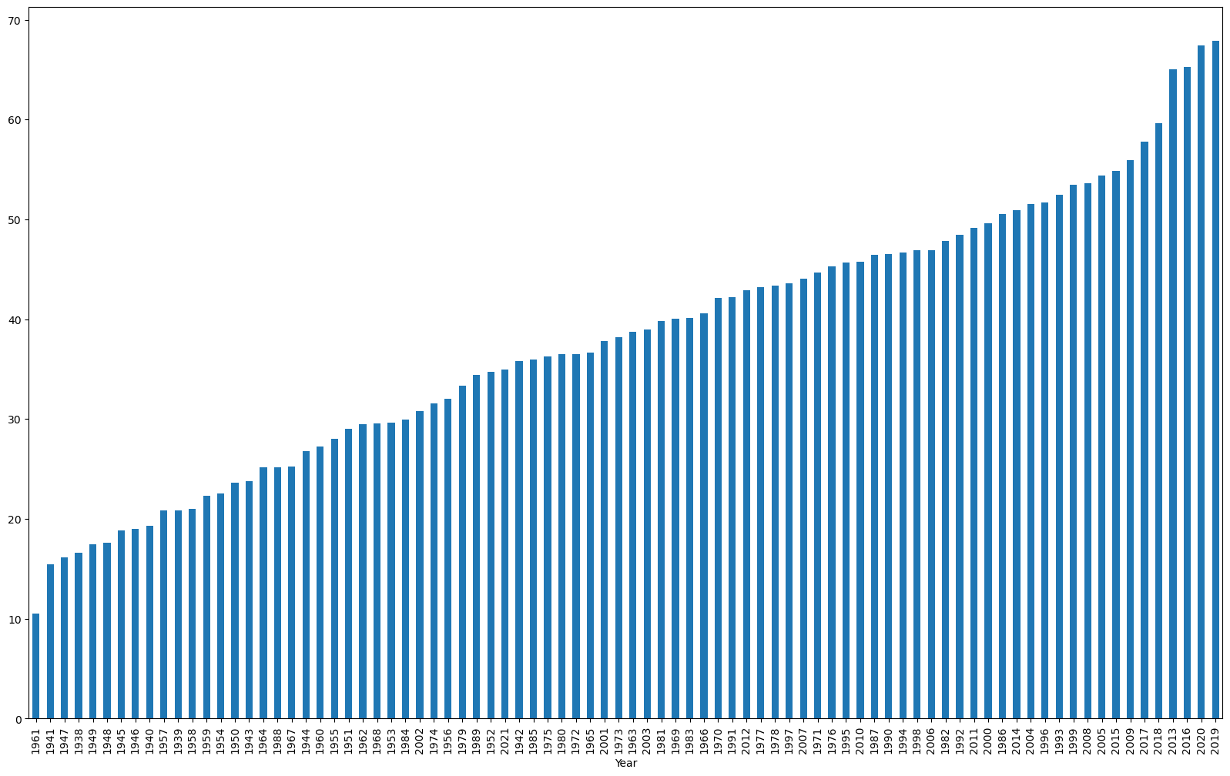

Grouped Bar Chart analysis (Fig 12 Average Barley in Rural Municipality with respect to Year

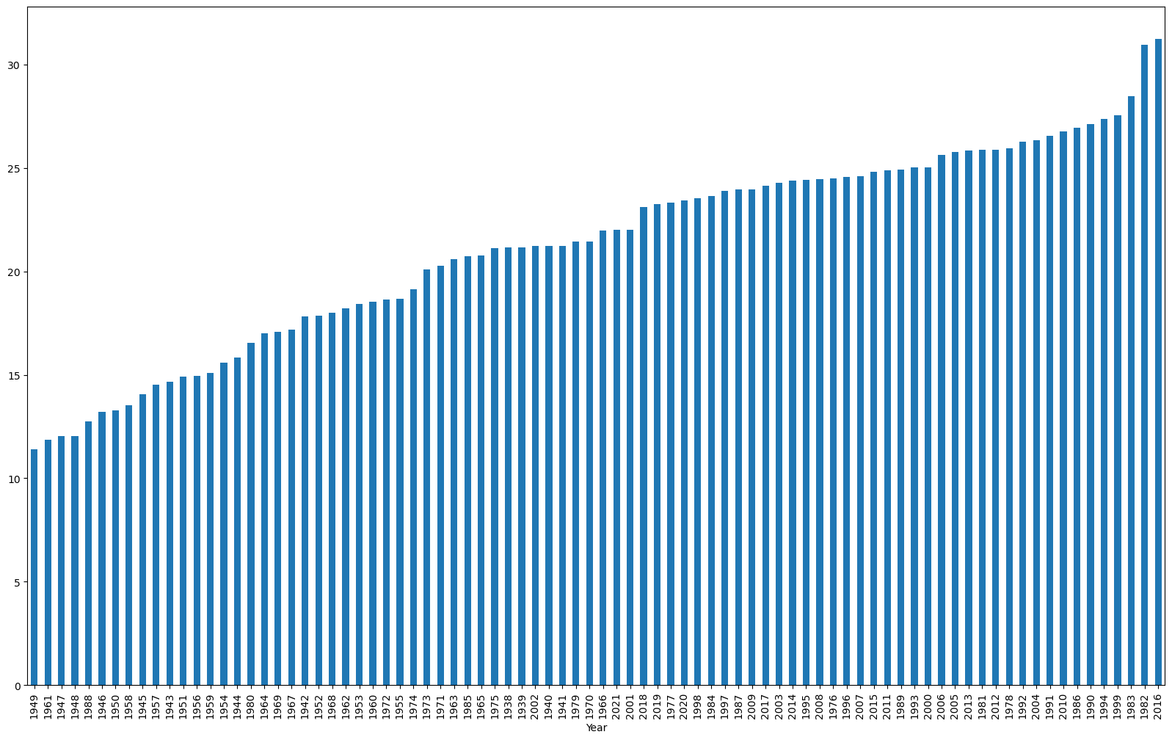

Grouped Bar Chart analysis (Fig 13 Average Fall Rye in Rural Municipality with respect to Year

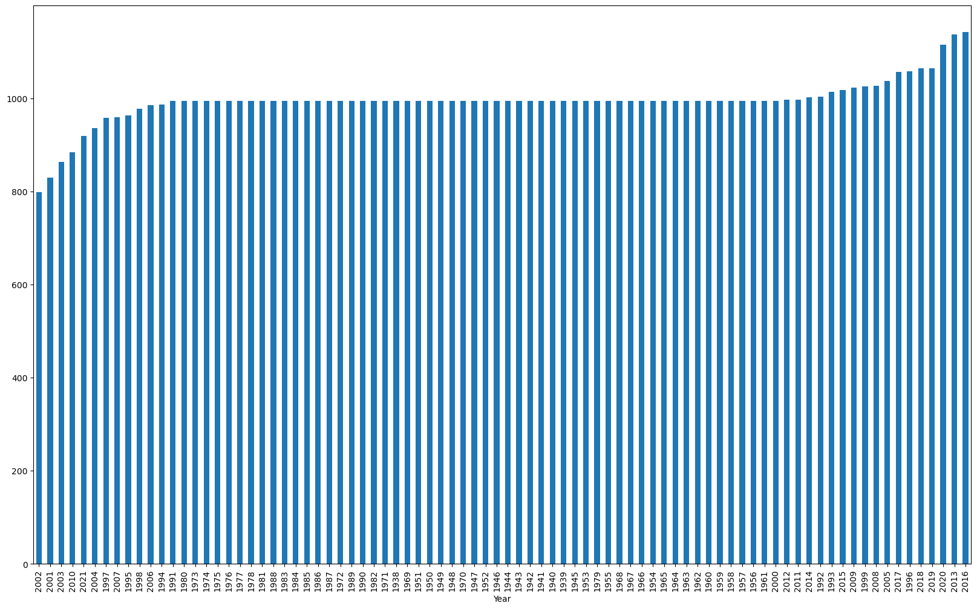

Grouped Bar Chart analysis (Fig 14 Average Canary Seed in Rural Municipality with respect to Year

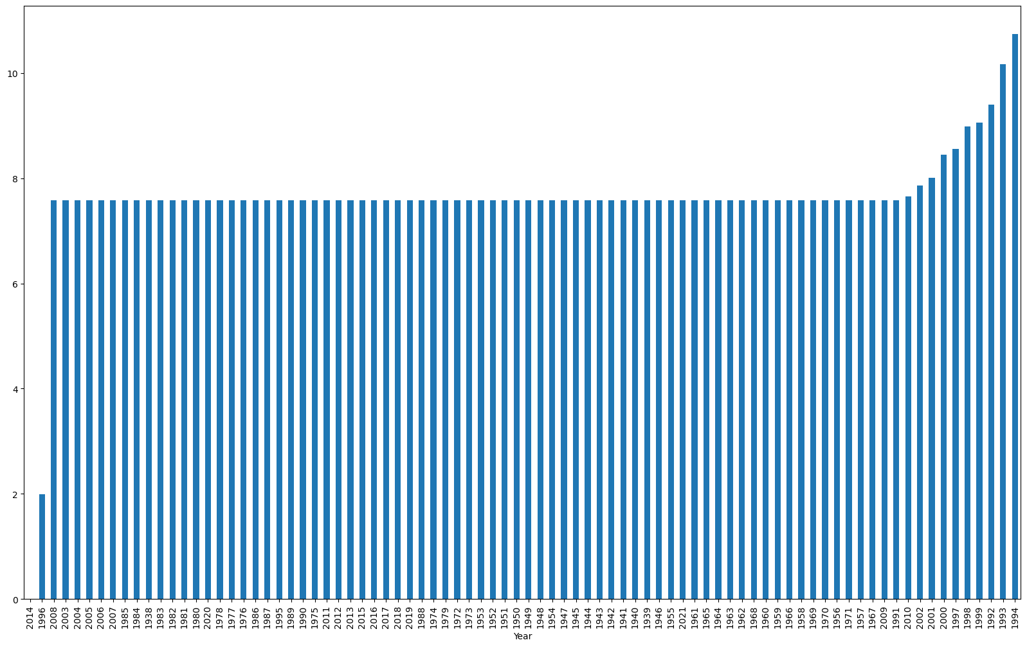

Grouped Bar Chart analysis (Fig 15 Average Spring Rye in Rural Municipality with respect to Year

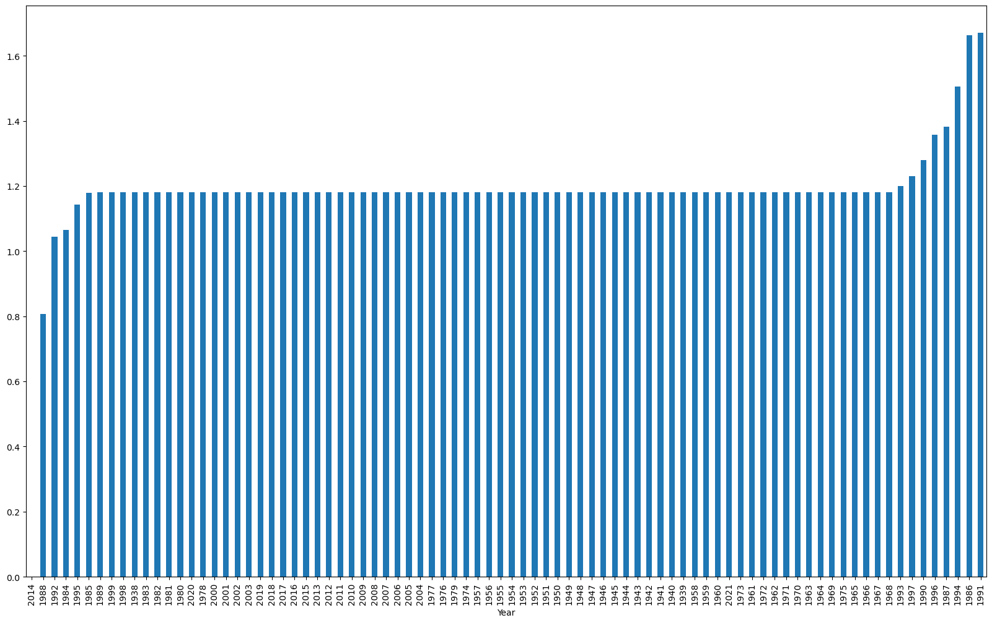

Grouped Bar Chart analysis (Fig 16 Average Tame Hay in Rural Municipality with respect to Year

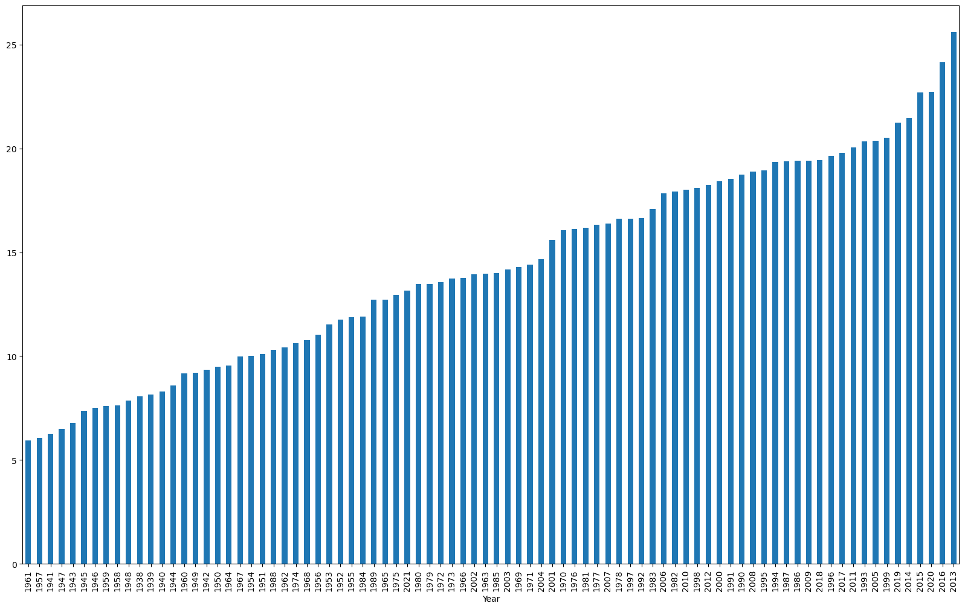

Grouped Bar Chart analysis (Fig 17 Average Flax in Rural Municipality with respect to Year

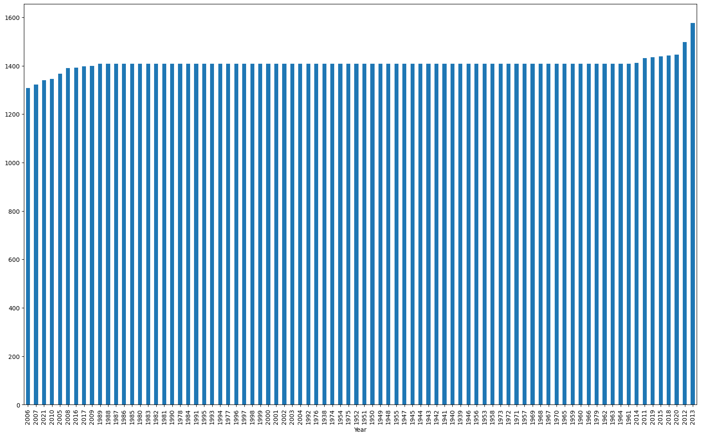

Grouped Bar Chart analysis (Fig 18 Average Chickpeas in Rural Municipality with respect to Year

The mean crop yield of Winter Wheat, Canola Spring Wheat, Oats, Lentils, Peas, Spring Wheat, Barley, Fall Rye, Canary Seed, Flax and Chickpeas was consistently high for the Year 2016, 2015, 2020 and 2018. Year 1993, 1999, 1994, 1991 have very high mean crop yield for Mustard, Sunflowers, Spring Rye, Tame Hay respectively.

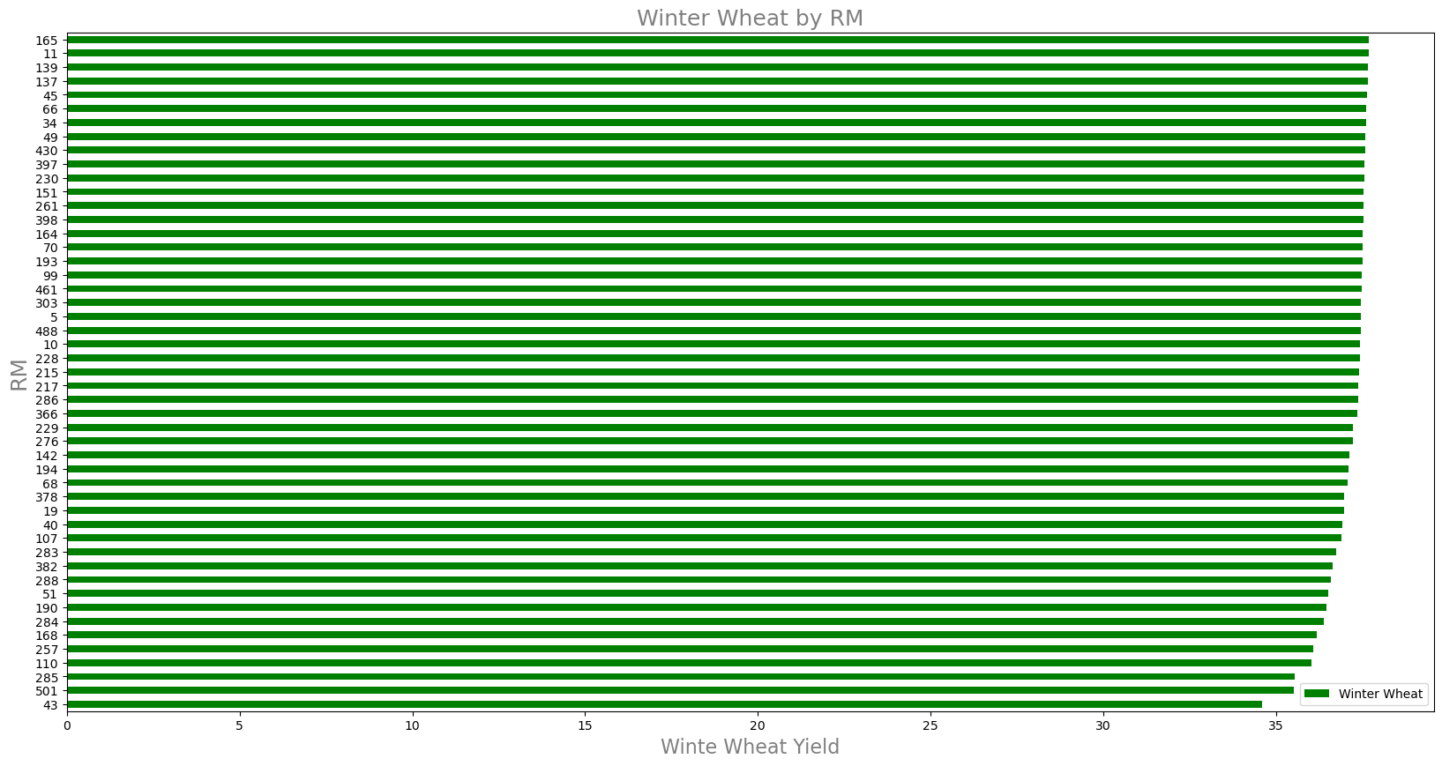

Grouped Bar Chart analysis (Fig 19 Average Winter Wheat in Rural Municipality with respect to RM

Grouped Bar Chart analysis (Fig 20 Average Canola in Rural Municipality with respect to RM

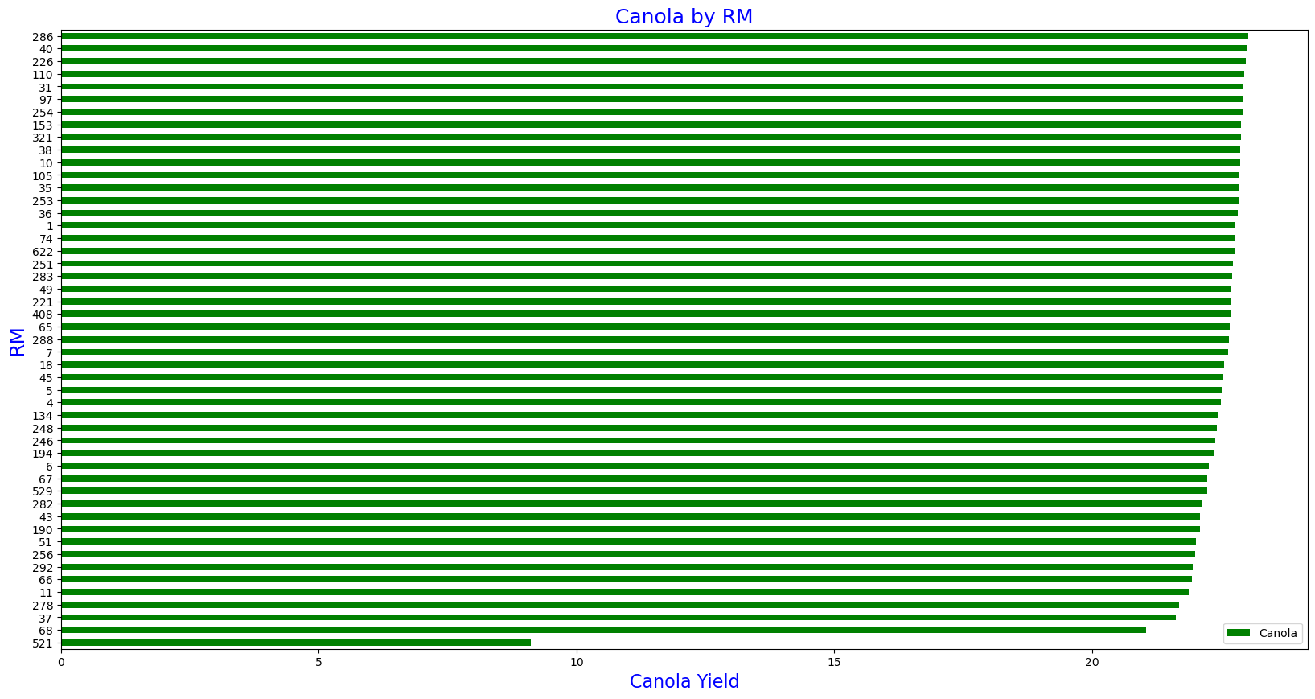

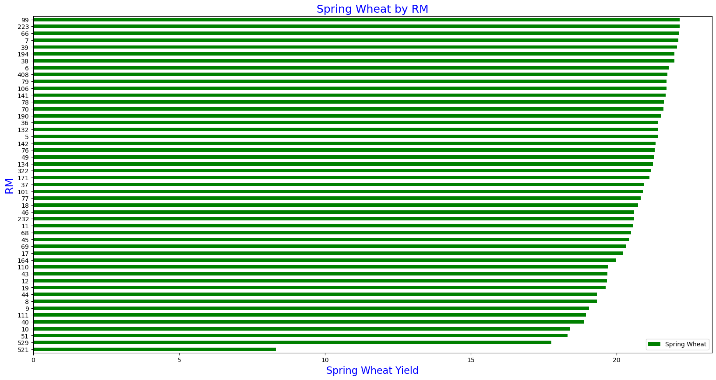

Grouped Bar Chart analysis (Fig 21 Average Spring Wheat in Rural Municipality with respect to RM

All the RMs except RMS 521 have mean crop yields above 20. This can be attributed to the same climatic factors and crop inputs methods in

those RMs.

1. **Mapping of crop yield in Rural Municipalities**

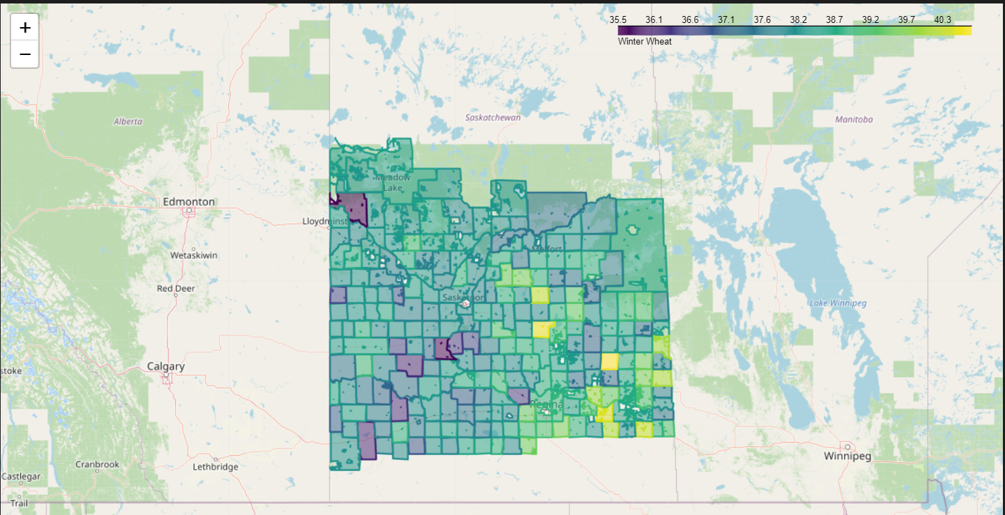

Fig 22: Map of Winter Wheat yields for the entire RMs

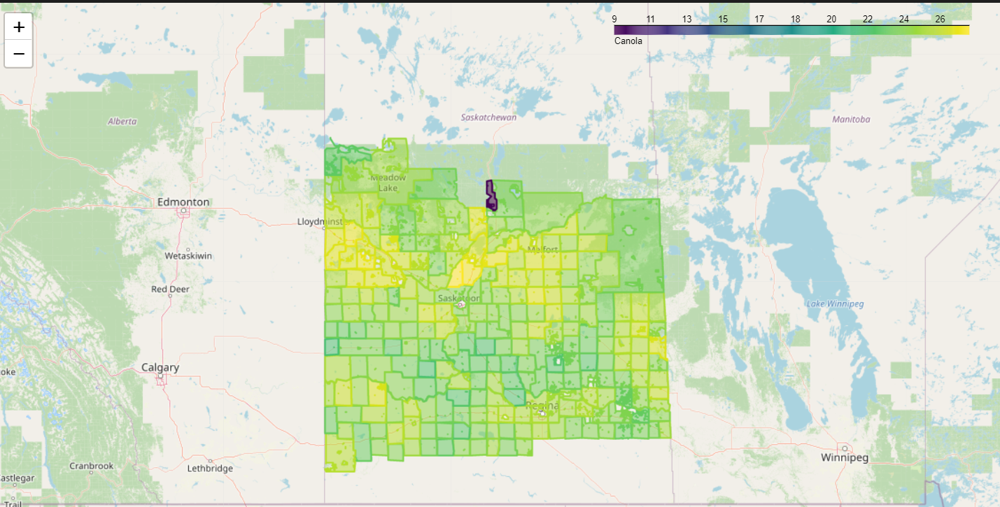

Fig 23: Map of Canola yields for the entire RMs

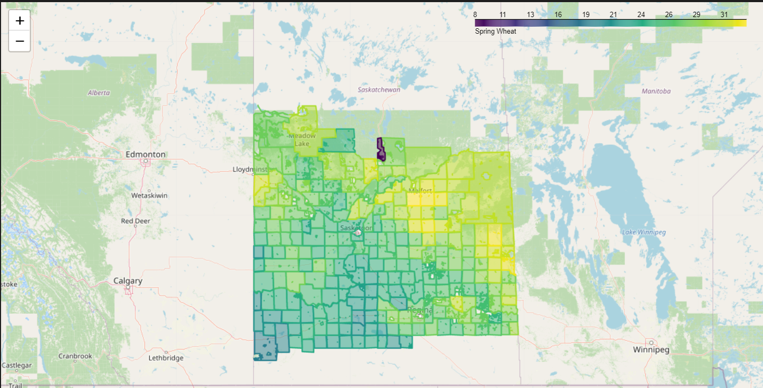

Fig 24: Map of Spring Wheat yields for the entire RMs

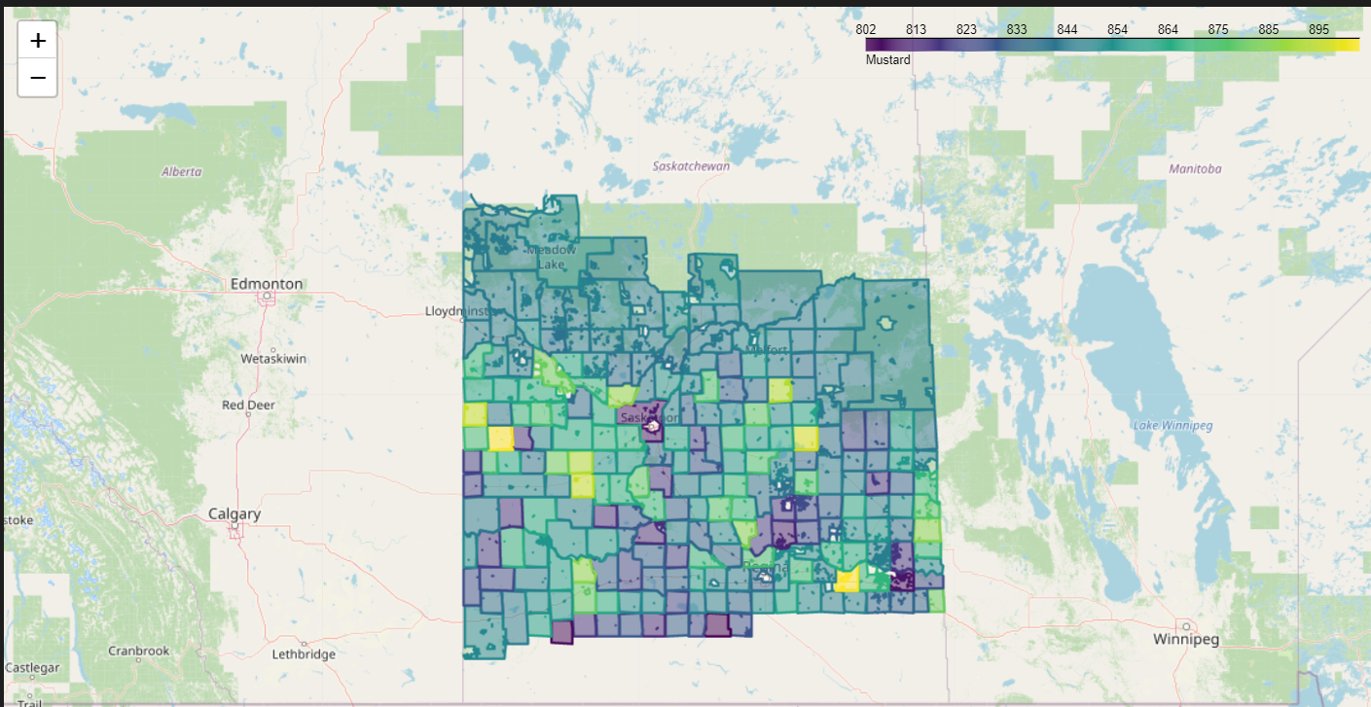

Fig 25: Map of Mustard yields for the entire RMs

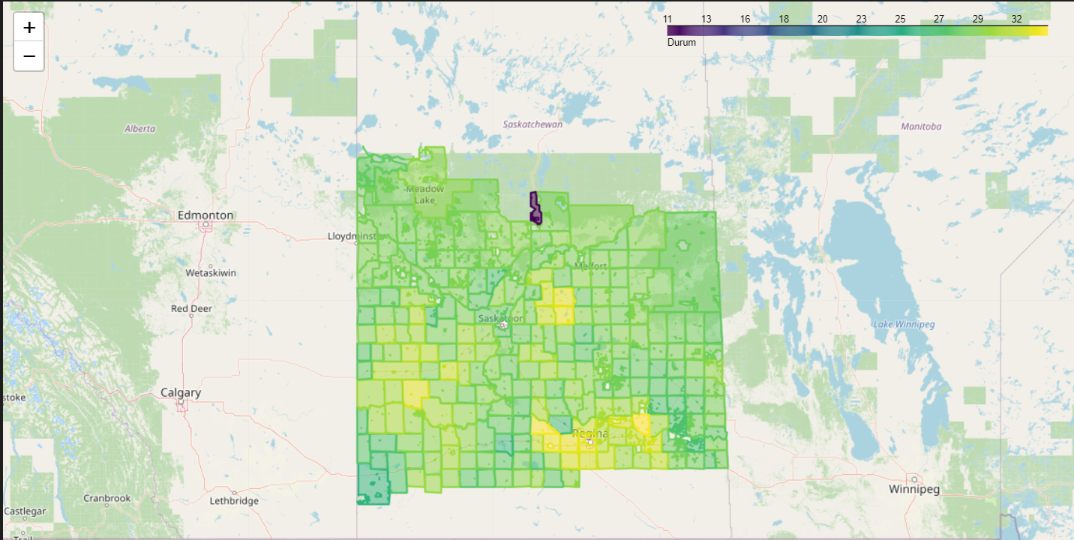

Fig 26: Map of Durum yields for the entire RMs

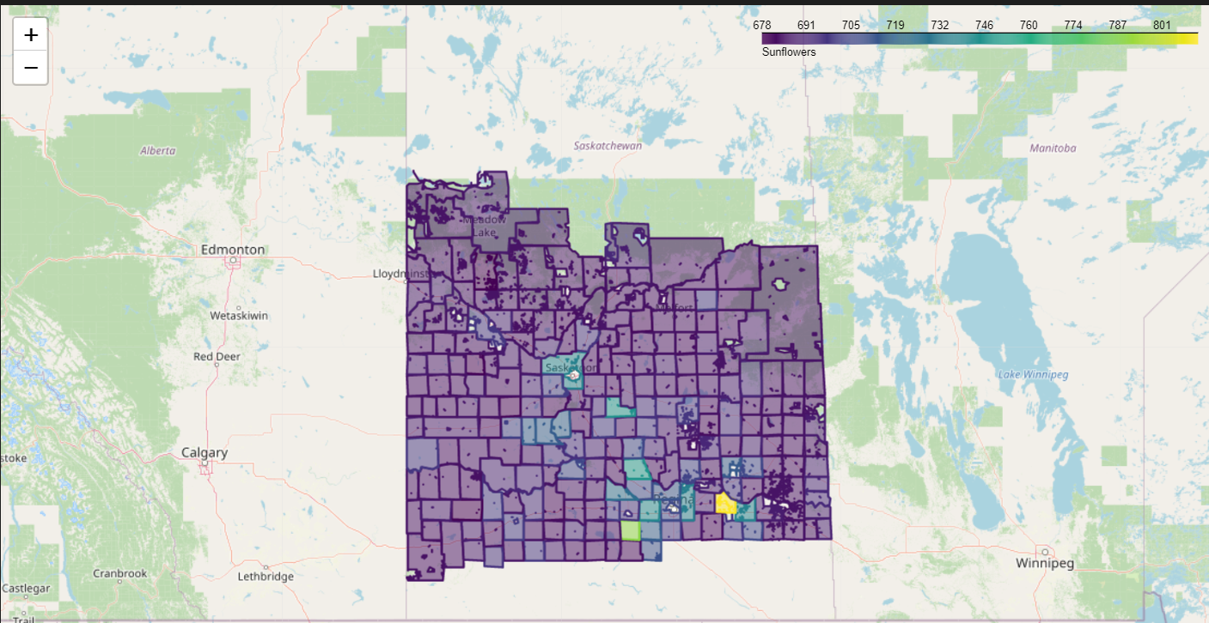

Fig 27: Map of Sunflowers yields for the entire RMs

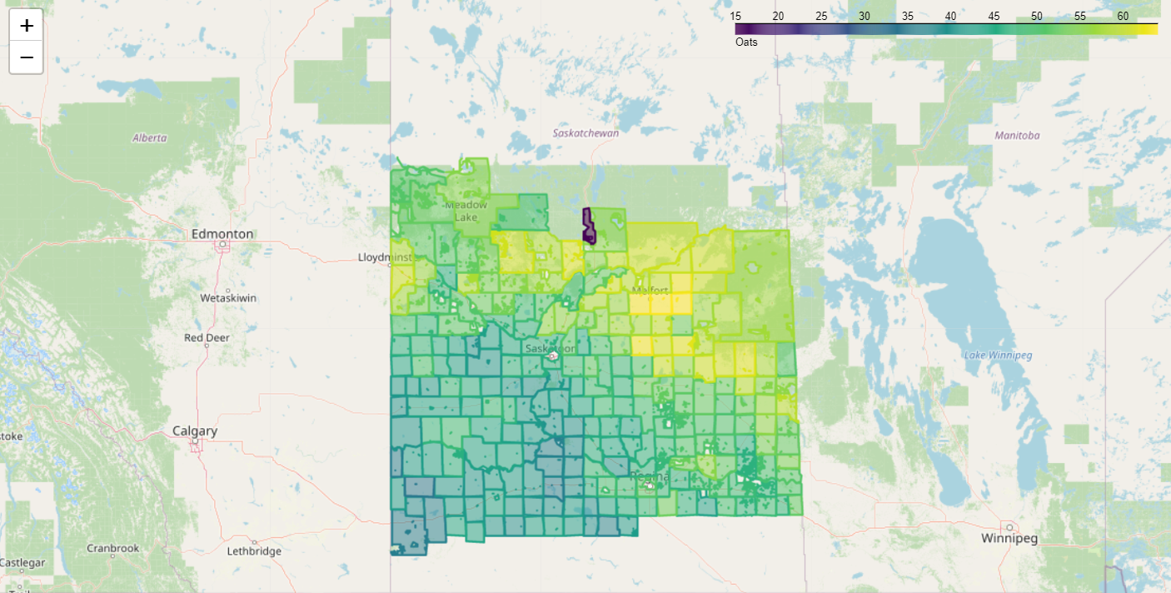

Fig 28: Map of Oats yields for the entire RMs

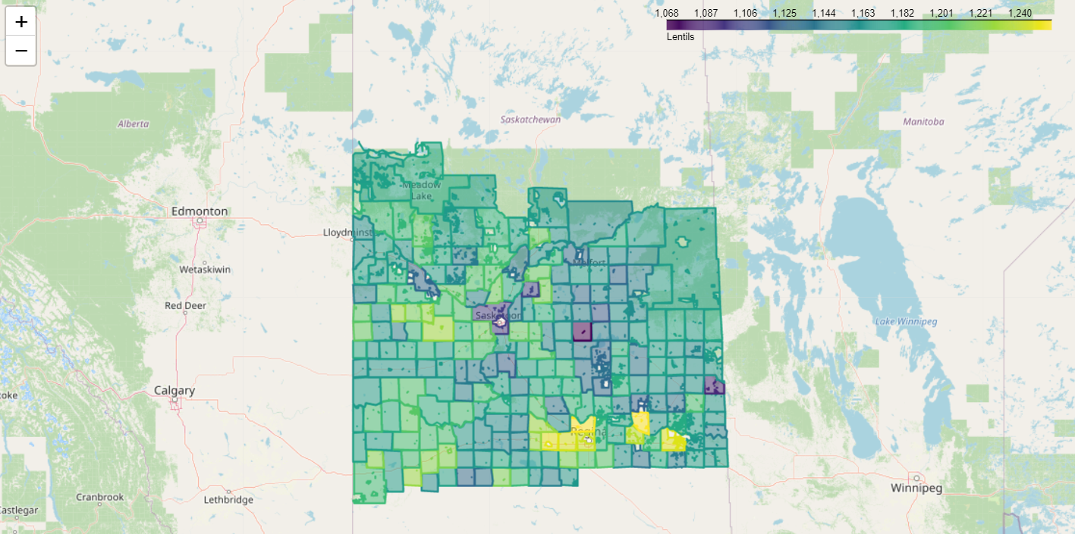

Fig 29: Map of Lentils yields for the entire RMs

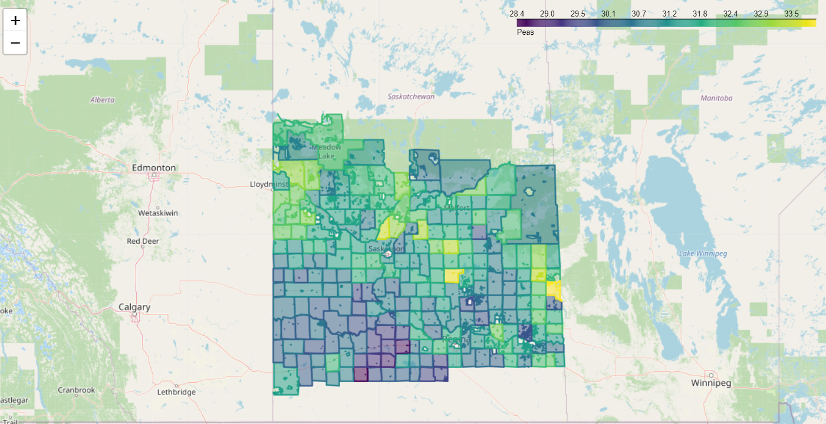

Fig 30: Map of Peas yields for the entire RMs

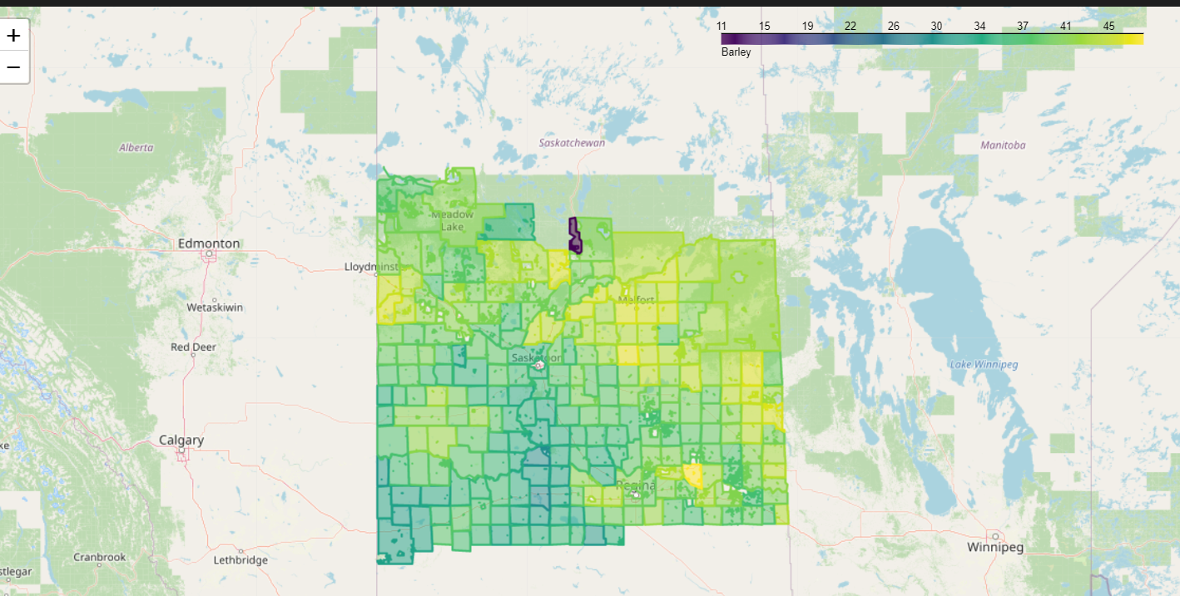

Fig 31: Map of Barley yields for the entire RMs

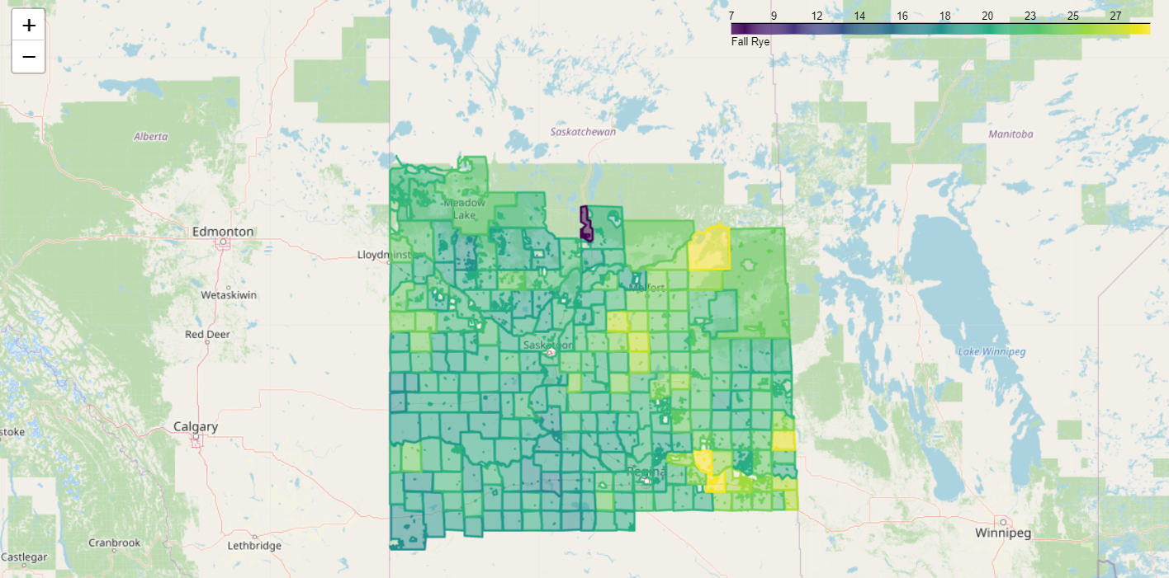

Fig 32: Map of Fall Rye yields for the entire RMs

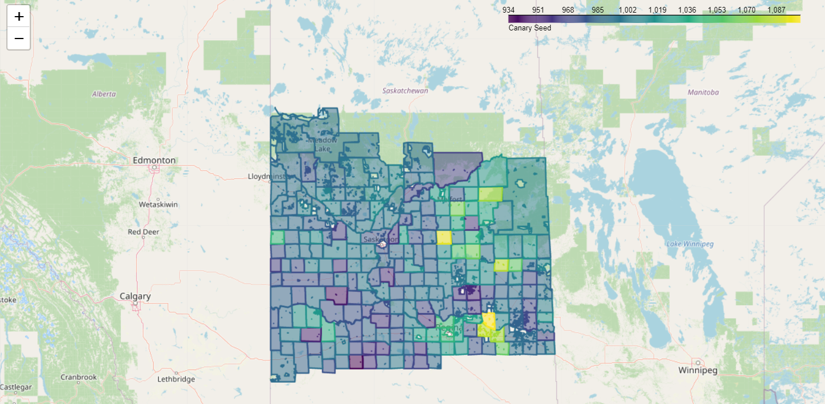

Fig 33: Map of Canary Seeds yields for the entire RMs

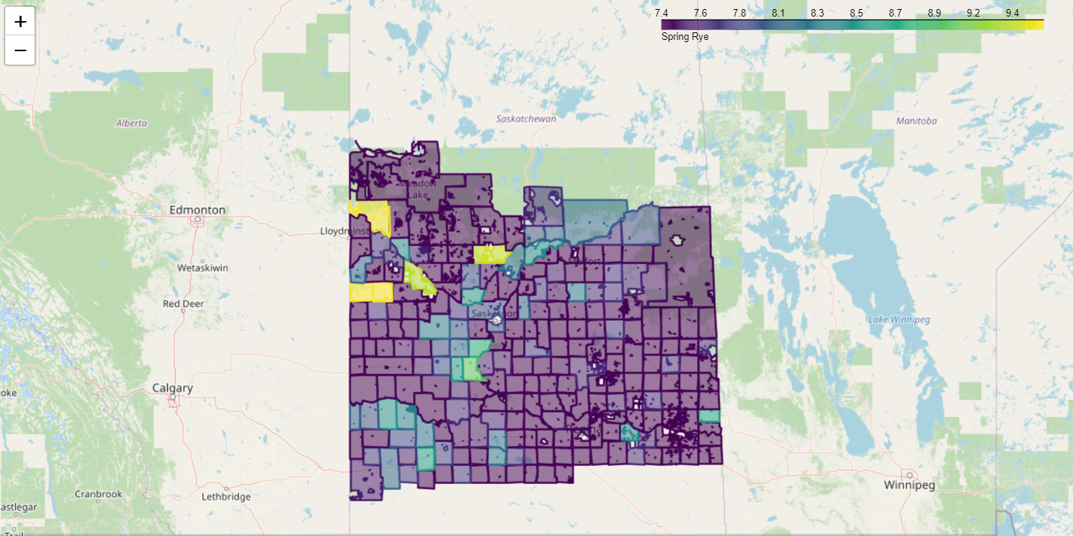

Fig 34: Map of Spring Rye yields for the entire RMs

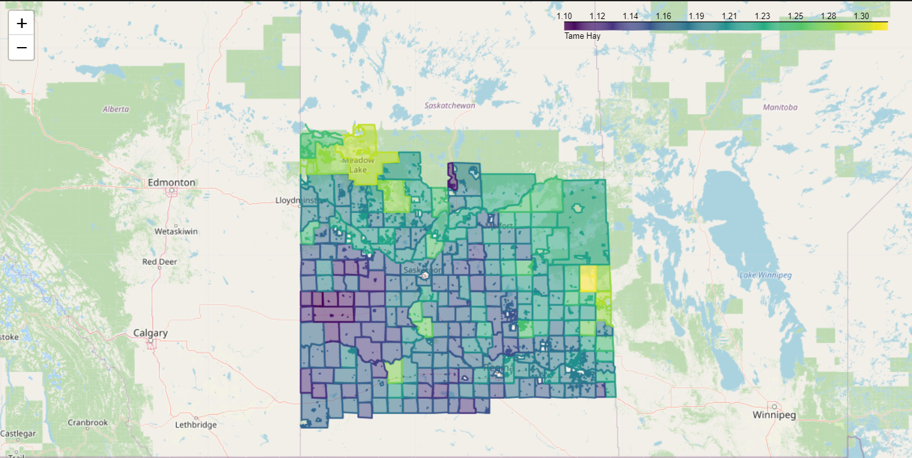

Fig 35: Map of Tame Hay yields for the entire RMs

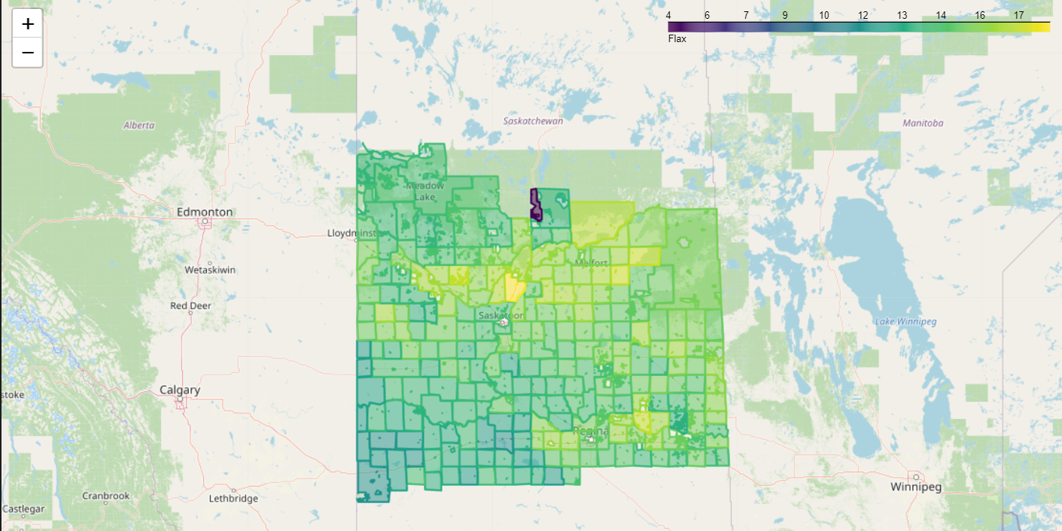

Fig 36: Map of Flax yields for the entire RMs

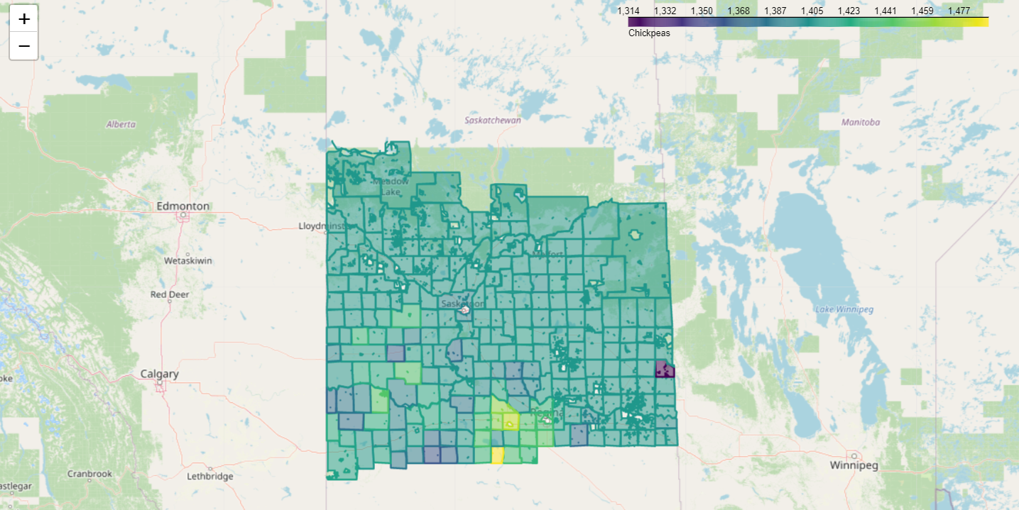

Fig 37: Map of Chickpeas yields for the entire RMs

Winter Wheat: RM 245 has mean crop yield of40.7 bu/ac while RM 316 has 15 bu/ac

Canola: RM 404 has the highest mean crop yield of 28.9 bu/ac in while RM 521 has the least 9.

Spring Wheat: RM 429 has the highest mean crop yield of 33.3 bu/ac in while RM 521 has 8.

Mustard: RM 155 has the highest mean crop yield of 903 bu/ac in while RM 101 has 802

Durum: RM 186 has the highest mean crop yield of 903 bu/ac in while RM 521 has 10.9

Sunflowers: RM 156 has the highest mean crop yield of 811 bu/ac in while RM has 684

Oats: RM 428 has the highest mean crop yield of 63.5 bu/ac in while RM 521 has 15

Lentils: RM 186 has the highest mean crop yield of 1254.6 bu/ac in while RM 339 has 1067

Peas: RM 271 has the highest mean crop yield of 33.9 bu/ac in while RM 106 has 28

Barley: RM 186 has the highest mean crop yield of 48 bu/ac in while RM 521 has 11

Fall Rye: RM 486 has the highest mean crop yield of28.49 bu/ac in while RM 521 has 7

Canary Seed: RM 186 has the highest mean crop yield of 1100 bu/ac in while RM 106 has 934

Spring Rye: RM 333 has the highest mean crop yield of 1.32/ac in while RM 183 has 7.39

Tame Hay: RM 410 has the highest mean crop yield of 9.54bu/ac in while RM 290 has 1.1

Flax: RM 403 has the highest mean crop yield of 18.5 bu/ac in while RM521 has 4.01

Chickpeas: RM 102 has the highest mean crop yield of 1491 bu/ac in while RM 241 has 1314.

The mean crop yield in all the RMs are generally below the average crop yields in Canada. This could be attributed to climate change factors and crop inputs. RM 521 has the least crop yields for Canola, spring wheat, Durum, Oats, Barley, and Fall Rye. This could be attributed to poor agronomic practices and crop management.

1. **Supervised Machine Learning**

Linear Regression Analysis

1. The R-squared score of **0.53** suggests that the model explains 53% of the variability in the Canola values based on the Year values. R-squared is a statistical measure that represents the proportion of the variance for a dependent variable that's explained by Year or Canola in a regression model. Therefore, the higher the R-squared score, the better the model fits the data. However, an R-squared score of 0.53 indicates that there may be other variables or factors that also influence the Canola values.
2. The Mean Absolute Error (MAE) is a measure of the average difference between the actual and predicted values. In this case, the MAE value of **5.84** indicates that on average, the model's predictions are off by 5.84 units from the actual values. Since the MAE value is specific to the scale of the target variable, it's difficult to make a general interpretation of whether a value of **5.84** is considered high or low without additional context or comparison to other models or benchmarks. However, in general, a lower MAE value indicates better predictive performance of the model.
3. **Predictions: [23.63004597 12.6814688 24.05114509 16.05026178 18.57685651]**

**Actual values: Year Values**

**2011 26.300000**

**1938 0.000000**

**1996 16.600000**

**1960 24.146796**

**1950 24.146796 Name: Canola, dtype: float64**

The result shows the predicted values of the canola production for the first five samples in the test set and the corresponding actual values. The predicted values are [23.63004597, 12.6814688, 24.05114509, 16.05026178, 18.57685651], and the actual values are [26.3, 0.0, 16.6, 24.146796, 24.146796]. The predicted value for the first sample in the test set is 23.63, which is close to the actual value of 26.3. Similarly, the predicted value for the third sample in the test set is 24.05, which is very close to the actual value of 16.6. However, the predicted value for the second sample is 12.68, which is far off from the actual value of 0.0.

Overall, it the model has performed reasonably well in predicting the canola production values, but there is certainly room for improvement, especially in predicting the values that are far off from the actual values.

**Verification of Prediction**

There are several ways to verify if the model has performed well in predicting the canola production values. Here are a few commonly used methods:

R-squared value: The R-squared value measures how well the model fits the data. It ranges from 0 to 1, with 1 indicating a perfect fit. A high R-squared value indicates that the model explains a large proportion of the variability in the data.

Mean absolute error (MAE): MAE measures the average absolute difference between the actual and predicted values. A lower MAE indicates that the model is better at predicting the actual values.

Mean squared error (MSE): MSE measures the average squared difference between the actual and predicted values. It gives higher weight to larger errors. A lower MSE indicates that the model is better at predicting the actual values.

R-squared: A value close to 1 indicates a good fit.

MAE: A lower value indicates better performance.

MSE: A lower value indicates better performance.

The R-squared score of 0.53 indicates that the model explains 53% of the variance in the canola production values. While this is not a perfect fit, it still suggests that the model has some predictive power. The Mean Absolute Error (MAE) of 5.84 suggests that, on average, the model's predictions are off by about 5.84 units from the actual canola production values. This value needs to be interpreted in the context of the range and scale of the canola production values. Therefore, the combination of R-squared score and MAE suggests that the model has performed reasonably well in predicting the canola production values. However, further analysis may be needed to fully evaluate the model's performance, such as comparing it to other models or using additional evaluation metrics.

**ARIMA MODEL**

**SARIMAX Results**

**==============================================================================**

**Dep. Variable: Canola No. Observations: 44**

**Model: ARIMA(2, 1, 3) Log Likelihood -160.414**

**Date: Sun, 26 Feb 2023 AIC 332.829**

**Time: 11:50:14 BIC 343.396**

**Sample: 0 HQIC 336.725**

**- 44**

**Covariance Type: opg**

**==============================================================================**

**coef std err z P>|z| [0.025 0.975]**

**------------------------------------------------------------------------------**

**ar.L1 -0.2975 0.361 -0.823 0.410 -1.006 0.411**

**ar.L2 -0.9978 0.164 -6.102 0.000 -1.318 -0.677**

**ma.L1 -0.6816 1099.564 -0.001 1.000 -2155.788 2154.425**

**ma.L2 0.6689 350.664 0.002 0.998 -686.620 687.958**

**ma.L3 -0.9873 1085.590 -0.001 0.999 -2128.705 2126.731**

**sigma2 91.1131 1e+05 0.001 0.999 -1.96e+05 1.96e+05**

**===================================================================================**

**Ljung-Box (L1) (Q): 0.03 Jarque-Bera (JB): 6.46**

**Prob(Q): 0.86 Prob(JB): 0.04**

**Heteroskedasticity (H): 0.81 Skew: 0.95**

**Prob(H) (two-sided): 0.70 Kurtosis: 3.02**

**===================================================================================**

This is the summary output of a SARIMAX (Seasonal Autoregressive Integrated Moving Average with Exogenous Variables) model fitted to a time series of Canola values. The model has an order of (2,1,3), which means it includes 2 autoregressive terms, 1 difference to make the series stationary, and 3 moving average terms. The table shows the estimated coefficients for each term, as well as their standard error, z-statistic, and p-value. The Ljung-Box statistic is a test for the absence of serial correlation in the residuals of the model, and the probability of the test (Prob(Q)) is shown for the first lag. The Jarque-Bera statistic is a test for normality of the residuals, and the probability of the test (Prob(JB)) is shown. The heteroskedasticity statistic (H) is also shown, which tests for the presence of heteroskedasticity in the residuals. Overall, the model has an AIC (Akaike Information Criterion) of 332.829, which is a measure of the model's goodness-of-fit, and it suggests that this model provides an acceptable fit to the data.

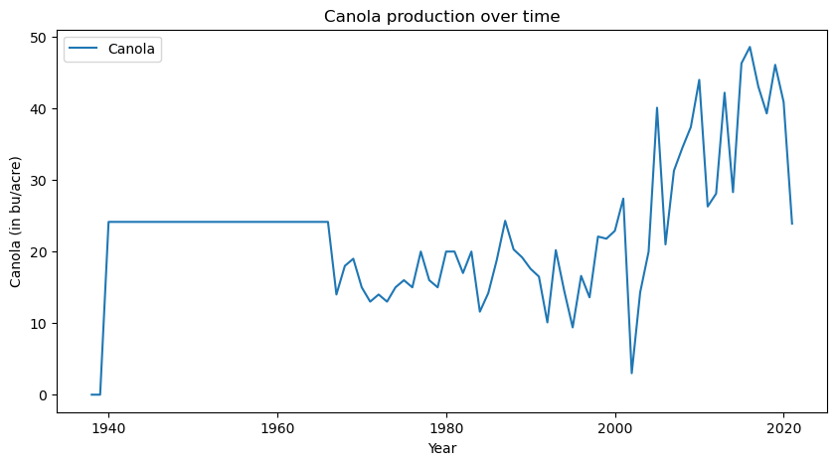

Fig 38: Time series graph for Canola yield from 1940 to 2020

From Fig 38, there was increase in Canola yield from 1940 until around 1965 when yield declined through 2000. Canola yield kept rising from 2000 to 2020. The decline in Canola yield could be attributed to change in climatic factors such as precipitation, sunshine, temperature and agronomic practices.

1. **Unsupervised Machine Learning**

Clustering Analysis

Mean and standard deviation of each feature for each cluster

Cluster Means:

Winter Wheat_mean Canola_mean Spring Wheat_mean Mustard_mean \

Cluster

0 38.399469 24.334452 28.228878 845.393293

1 37.995797 23.805906 23.135184 836.020096

2 38.335846 24.234545 26.178742 849.736332

Durum_mean Sunflowers_mean Oats_mean Lentils_mean Peas_mean \

Cluster

0 28.513727 688.204401 52.468810 1166.646123 31.595635

1 29.014549 695.056475 41.777767 1172.968584 30.115493

2 29.300212 693.569167 47.660850 1174.008300 31.236814

Barley_mean ... Oats_std Lentils_std Peas_std Barley_std \

Cluster ...

0 40.657865 ... 21.841411 80.211754 5.789255 16.490713

1 34.917441 ... 17.425028 206.939683 5.382760 14.789313

2 38.620718 ... 20.605781 213.027553 5.719448 16.384882

Fall Rye_std Canary Seed_std Spring Rye_std Tame Hay_std \

Cluster

0 6.770639 87.822929 1.907841 0.265364

1 7.846967 120.000757 1.796481 0.267922

2 7.615804 140.079771 1.769361 0.256013

...

1 0.736853 57.568529

2 1.022414 30.874433

The result shows the mean and standard deviation of each feature for each of the three clusters. Looking at the mean values, it can be seen that there are differences in the average yield of each crop across the clusters. For example, Cluster 2 has a higher mean yield for Winter Wheat, Canola, Spring Wheat, and Durum compared to the other clusters. In contrast, Cluster 1 has the lowest mean yield for several crops, including Canola, Spring Wheat, and Oats. Cluster 0 has the highest mean yield for Mustard and Sunflowers. These differences in mean yield can help identify which crops are performing better or worse in each cluster. From the standard deviation values, it can be seen that there are also differences in the variability of crop yield across the clusters. For example, Cluster 1 has a higher standard deviation for Lentils and Barley compared to the other clusters, suggesting that yields for these crops are more variable within Cluster 1. In contrast, Cluster 2 has a higher standard deviation for Canary Seed and Tame Hay. Therefore, by comparing the mean and standard deviation values across the clusters, we can identify patterns and differences in crop yield performance that may be useful for decision-making.

**The Elbow method**

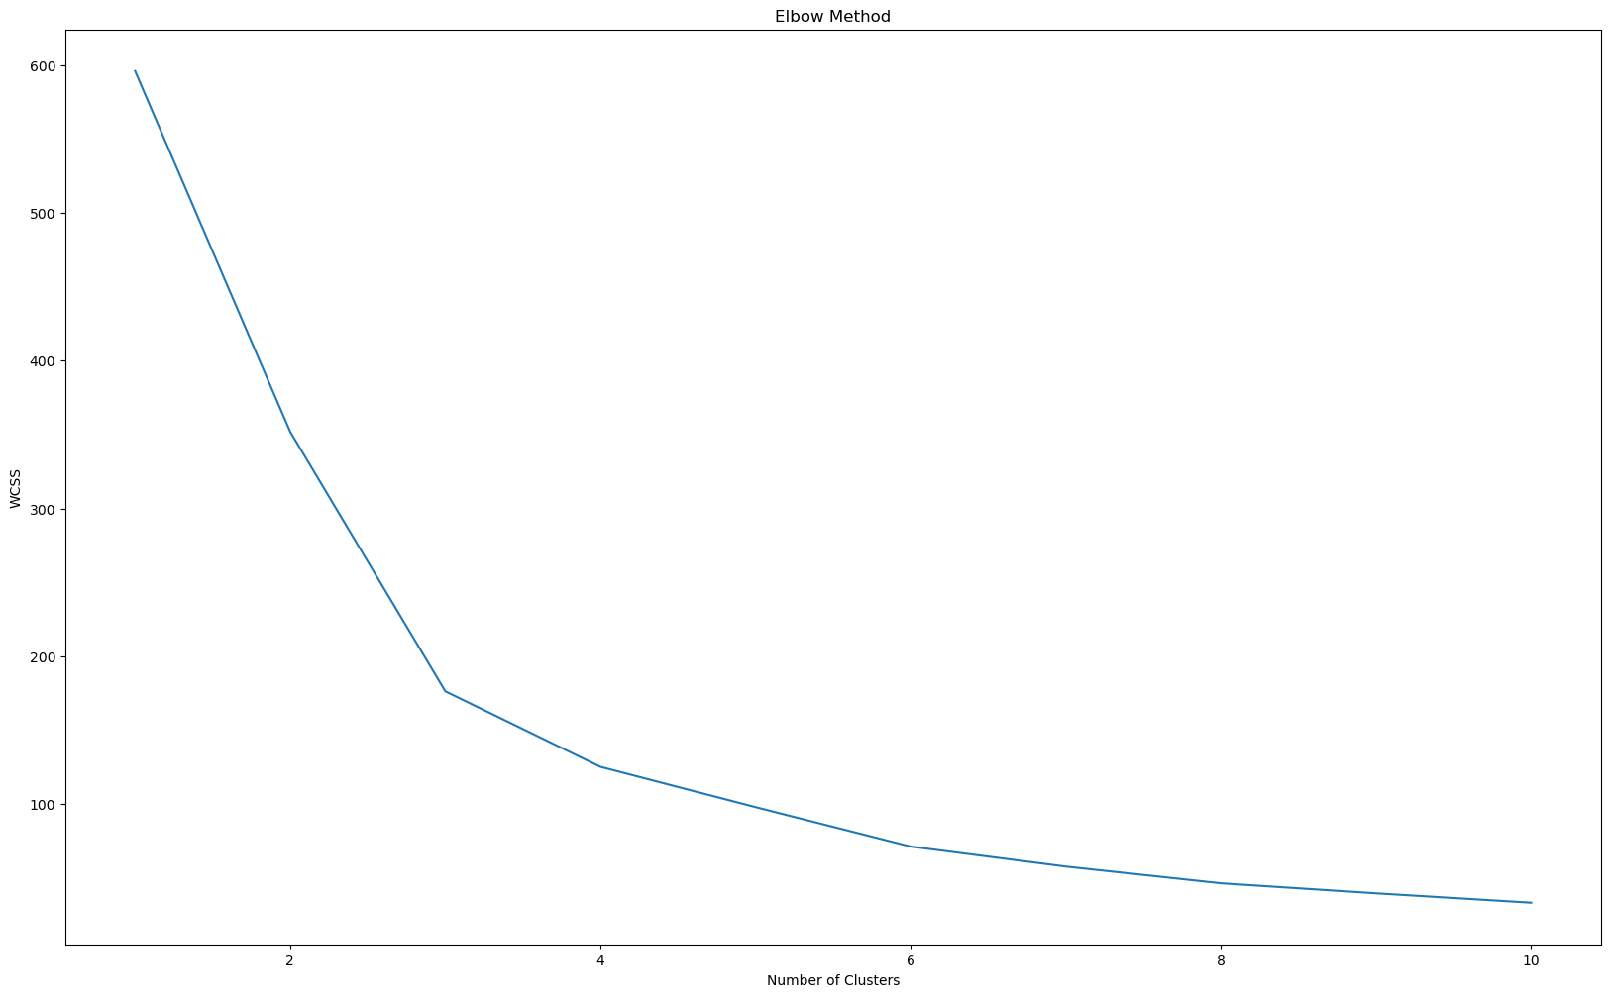

Fig 39: Elbow graph showing number of clusters vs WCSS

In the elbow plot generated by the model, the x-axis represents the number of clusters (k) and the y-axis represents the within-cluster sum of squared errors (WCSS). As the number of clusters increases, the WCSS generally decreases because more clusters means smaller within-cluster distances. The optimal number of clusters can be determined by identifying the "elbow" point, which is the point where the rate of decrease in WCSS begins to level off. Therefore, in the context of the elbow plot generated by the model, we can interpret that the optimal number of clusters may be 2 or 3, as there is no clear "elbow" point in the plot. It is important to note that the determination of the optimal number of clusters is not always straightforward and may require additional analysis and expert knowledge.

**The Scatter Plot**

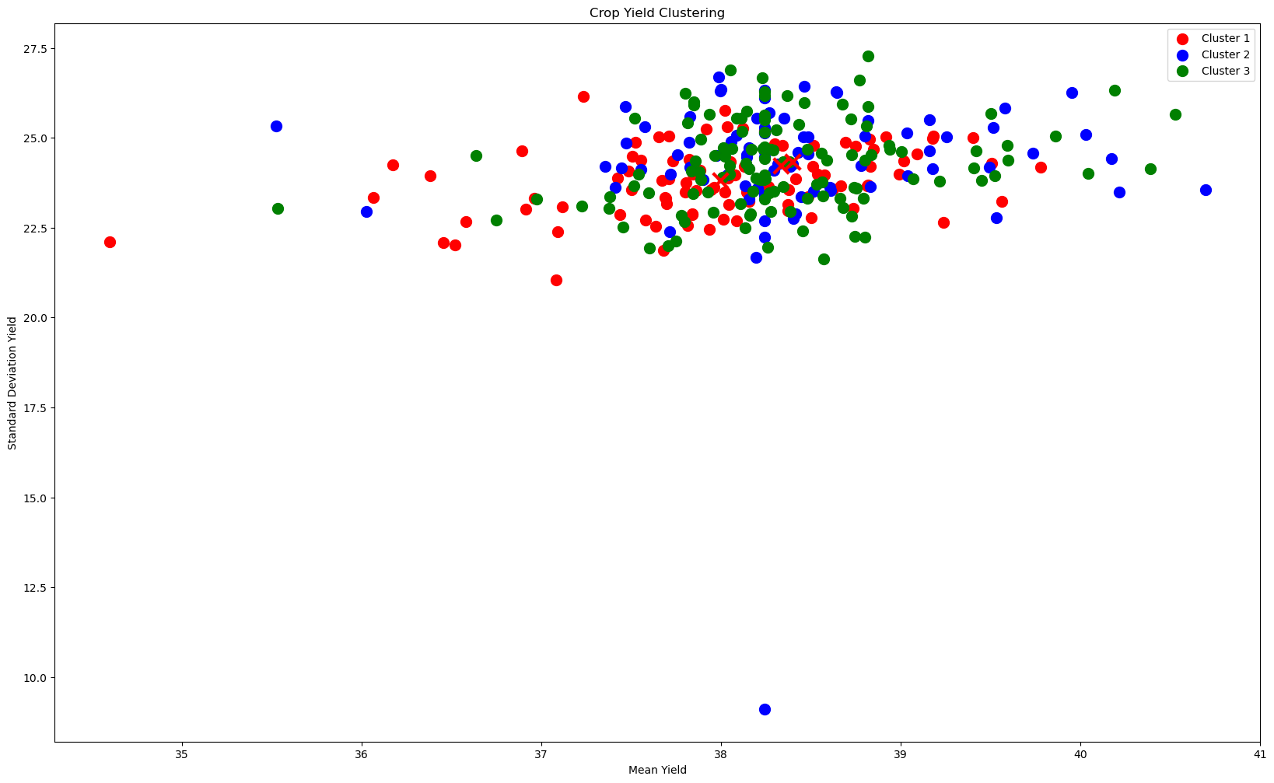

Fig 40: Scatter plot showing clusters formed by the k-means algorithm

The model created a scatter plot that visualizes the clusters formed by the k-means algorithm. The plot shows the data points in two dimensions: the x-axis represents the mean yield of crops and the y-axis represents the standard deviation yield of crops. The plot shows three clusters, each represented by a different color: red, blue, and green. The red cluster has data points with relatively low mean yields and low standard deviation yields, while the blue cluster has data points with relatively high mean yields and high standard deviation yields. The green cluster has data points with relatively high mean yields and low standard deviation yields. The plot also shows the cluster centers as a red X-mark. These are the average values of mean yield and standard deviation yield for each cluster. The plot is titled "Crop Yield Clustering" and includes x and y axis labels and a legend that identifies each cluster by its color.

Overall, this plot helps to visualize how the k-means algorithm has grouped the crops based on their yield characteristics, and can provide insights into how to optimize crop yields in the future.

**CONCLUSIONS**

* The strong correlation values in Oats/Barley, SpringWheat/Oats, Flax/SpringWheat might be due to similar climatic factors such as precipitation, sunshine, and inputs. This could also mean that these group of crops can be cultivated in the same region.
* The average crop yield of RM 521 for most of the crops were very low and this could be attributed to poor crop management system.
* The mean crop yield in all the RMs are generally below the average crop yields in Canada. This could be attributed to climate change factors and crop inputs. RM 521 has the least crop yields for Canola, spring wheat, Durum, Oats, Barley, and Fall Rye. This could be attributed to poor agronomic practices and crop management.
* The model performed reasonably well in predicting the canola production values, but there is certainly room for improvement, especially in predicting the values that are far off from the actual values.
* The combination of R-squared score and MAE suggests that the model has performed reasonably well in predicting the canola production values. However, further analysis may be needed to fully evaluate the model's performance, such as comparing it to other models or using additional evaluation metrics.
* The ARIMA model result has an AIC (Akaike Information Criterion) of 332.829, which is a measure of the model's goodness-of-fit, and it suggests that this model provides an acceptable fit to the data.
* In the cluster analysis, by comparing the mean and standard deviation values across the clusters, we can identify patterns and differences in crop yield performance that may be useful for decision-making.
* From the elbow method, in the context of the elbow plot generated by the model, it can be deduced that the optimal number of clusters may be 2 or 3, as there is no clear "elbow" point in the plot
* The scatter plot helps to visualize how the k-means algorithm has grouped the crops based on their yield characteristics, and can provide insights into how to optimize crop yields in the future.

**FUTURE WORK**

More data will be needed to investigate further the performance of crops in each RM from 1938 to 2021. The data should include the following:

* Records of average annual precipitation of each RM
* Records of average annual temperature of each RM
* Records of crop input methods
* Records of soil nutrient analysis of each RM

**REFERENCES**

1. O'Reilly Practical Statistics for Data Scientists second edition: Title: Practical Statistics for Data Scientists, 2nd Edition Author: Peter Bruce, Andrew Bruce, and Peter Gedeck Publisher: O'Reilly Media Year: 2021

ISBN: 978-1492072942

1. Python Data Science Handbook: Essential Tools for Working with Data Author: Jake VanderPlas Publisher: O'Reilly Media Year: 2016
2. ChatGPT